HOME EXERCISE HANDOUT

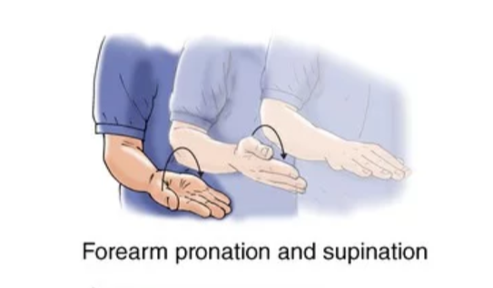
- Pronation (palm down)
  - Keep elbow at side during motion.

- Supination (palm up)
  - Keep elbow at side during motion.
Figure 1 Summit Medical Group

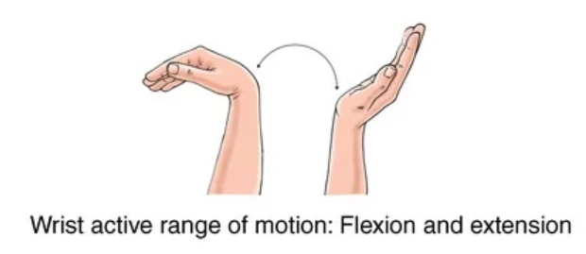
- Wrist Extension

- Wrist Flexion
Figure 2 Summit Medical Group

- Dart throwers (toward thumb)
Figure 3 Orfit.com

- Dart throwers (toward small finger)

10 second hold for each motion

