CMC OSTEOARTHRITIS BRACE HANDOUT

Exos Short Thumb Spica

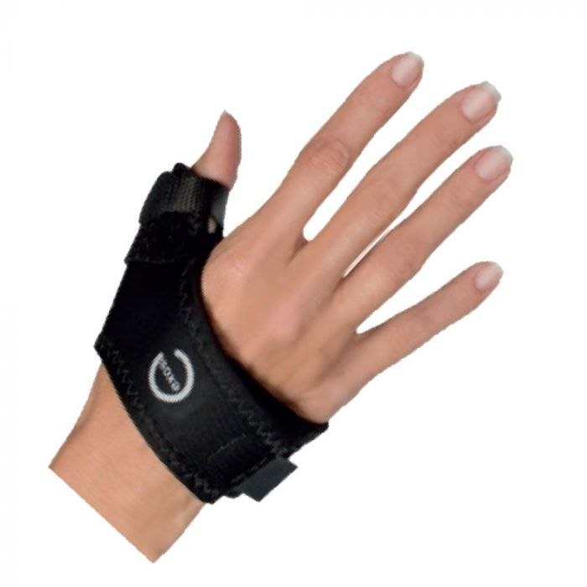

Djostore.com

Push Meta-Grip
Available on BraceLab.com

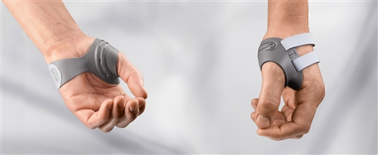

CMC Care Thumb Brace
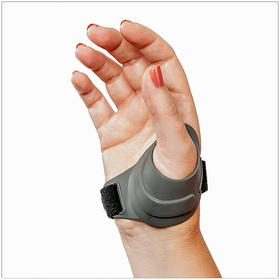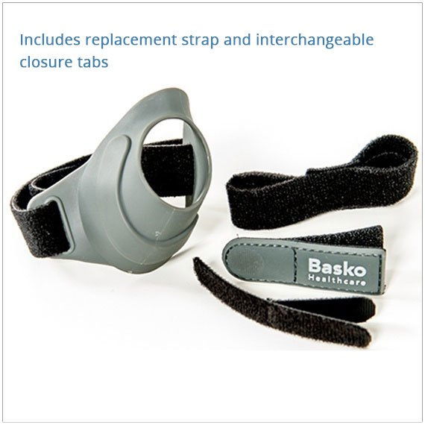
3pointproducts.com

