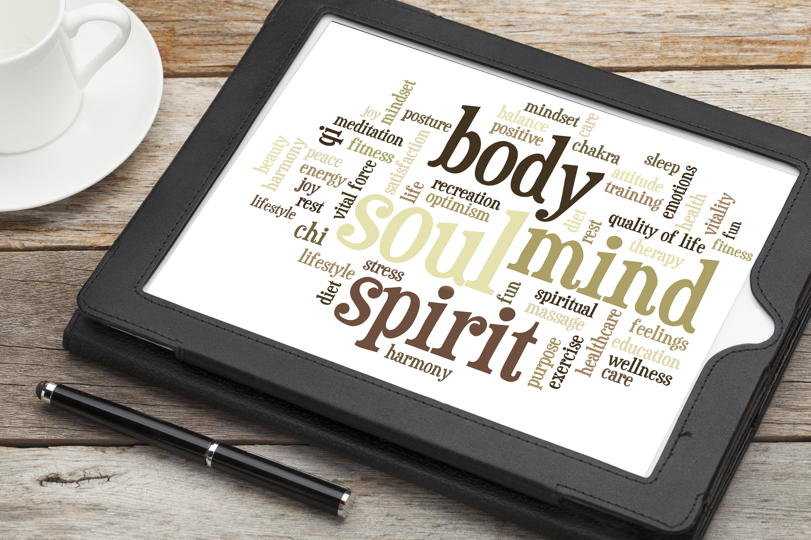  Sig: Wellness Studio is the home of the mind-body psychiatry practice of  Candace R. Good, MD  Sig: Wellness, LLC Mission Statement  To provide every client with an opportunity to meet with an experienced mental health provider who maintains an open mind to the benefits of complementary therapies. The studio setting promotes stress reduction while reinforcing that self-care requires practice, just like other fine arts. The space welcomes like-minded practitioners (yoga, nutrition, acupuncture) to co-locate services to create a community that supports emotional wellbeing.  ADDITIONAL SPACE AVAILABLE! |  | 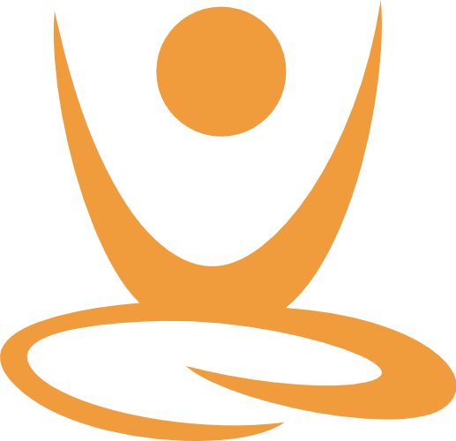  Website:  https://www.candacegoodmd.com  Sig: WELLNESS STUDIO 320 Rolling Ridge Dr., Suite 202 State College, PA 16801 Tel (814) 682-3880 Fax (814) 682-3881 |  | Sig: WELLNESS STUDIO  - A MIND-BODY APPROACH TO MENTAL HEALTH  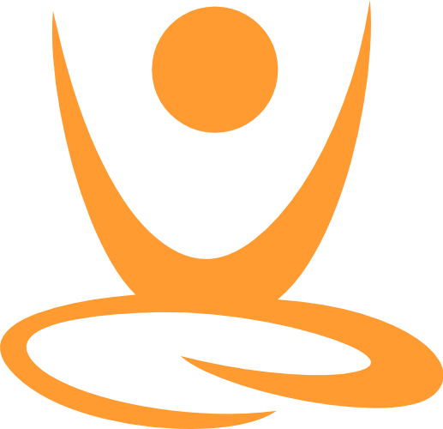

r
What is Ayurveda?  - Ayurveda is an ancient system of medicine rooted in the belief that mind-body balance is the key to optimal health.  - Ayurvedic practitioners prescribe a personalized wellness routine and diet to promote proper digestion and introduce herbal supplements only as needed.  Research now supports the mind-gut connection in psychiatry and many conditions, particularly recurrent depression, are believed to be caused by chronic inflammation in the body. Proper diet and activities such as meditation have been shown to decrease inflammatory markers. |  | Dr. Good is proud to share her new office space in 2019, shifting her psychiatric practice to provide lifestyle consultations for patients. 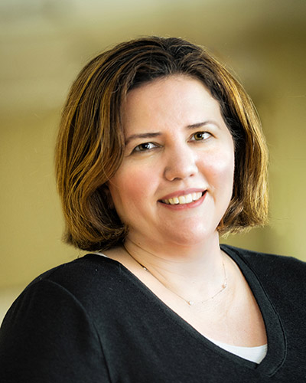  Studio Founder Bio  Dr. Good is board certified in general and child & adolescent psychiatry. She regularly practices yoga, pranayama, and other forms of meditation. In preparation for starting  Sig: Wellness, LLC, Dr. Good completed extensive training programs for health professionals from Wellcoaches and the Maharishi Ayurveda Association of America.  A proud Penn State University alum, she received her medical degree in 1999. She specialized in the care of children and adults with ADHD and served as chair of psychiatry at the Mount Nittany Medical Center as part of her clinical practice for Sunpointe Health (2007-2018).  Dr. Good enjoys knitting, freelance medical writing, and spending time with her family, especially her daughter and 2 rescue hounds.  https://www.candacegoodmd.com  Call or Text: (814) 682-3880 |  | “I am dedicating my available clinical time to sharing the practices that have helped me to feel more present for my patients and for my family. I still believe in psychiatric medications and have benefitted from them at various times in my own life, but the focus of my work at Sig:Wellness will be to empower patients to better understand their role in making the most of their other mental health treatments.”  General Information  - Target conditions include anxiety, depression and other stress-related conditions.  - Direct pay (cash) practice so Dr. Good cannot treat patients with Medicare or Medicaid due to program rules.  - Currently accepting adult patients, by provider referral, for collaborative care.  - Co-located services: A special thanks to Justine (Path to Calm) for her guidance in mindfulness. Look for her in the yoga room!

