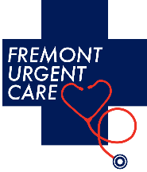 CLIENT SURVEY
We are committed to listening to the voice of our clients. This questionnaire is a valuable way for us to gather feedback, so we can improve our facility and services.

Fremont Urgent Care will make a donation to North Valley Community Foundation for every Client Survey we receive. North Valley Community Foundation - 99% of all donations reach the victims and their families. https://www.nvcf.org

Thank you for your assistance.
Question | Rate 1-10 | Comments
Do you feel we do an adequate job keeping you informed after injuries?
Are you receiving results in a timely manner for physicals and drug screens?
Do you find the staff helpful and professional?
Is your employee feedback positive about Fremont Urgent Care? If not, please comment.
Do you feel our quarterly seminars are valuable? (see website)
Are the wait times for injuries and/or physicals acceptable?
Would you be interested in after-hours drug testing?
Are you interested in obtaining reports via an online portal?
How can we improve Fremont Urgent Care?
How long have you been a client of Fremont Urgent Care?
Are you receiving our quarterly emailed newsletters?
Would you like us to contact you for a meeting and/or protocol review?
By: (optional) | Email:
Reply: EMAIL: Carole@fremonturgent.com or FAX: 510-796-1050

