Patient Name ______________________________ Date ______/______/______

General Health Review
Do you have any history of:
 Heart Disease |  Diabetes |  Depression
 Stroke |  Hypertension |  Suicidal Ideas
 Cancer |  Seizures |  Other: ____________________
 Arthritis |  Ulcers

Surgical History:
Any surgeries UNRELATED to pain? __________________________________________________________________________
Any surgeries RELATED to pain? _____________________________________________________________________________

Do you have any ALLERGIES to:
 Foods? Please list, with symptoms: ______________________________________________________________________
___________________________________________________________________________________________________________
 Medications? Please list, with symptoms: __________________________________________________________________
___________________________________________________________________________________________________________

Please list any intolerances to medications? What side effects did they cause? _____________________________________
___________________________________________________________________________________________________________

Do you take any blood thinning medications (e.g., ASA, Plavix, Coumadin, Warferin, etc.)? Yes  No

Do you bruise easily? Yes  No

Is there a possibility you are pregnant? Yes  No

Pain Assessment Tool
Please mark the diagram where you experience pain.

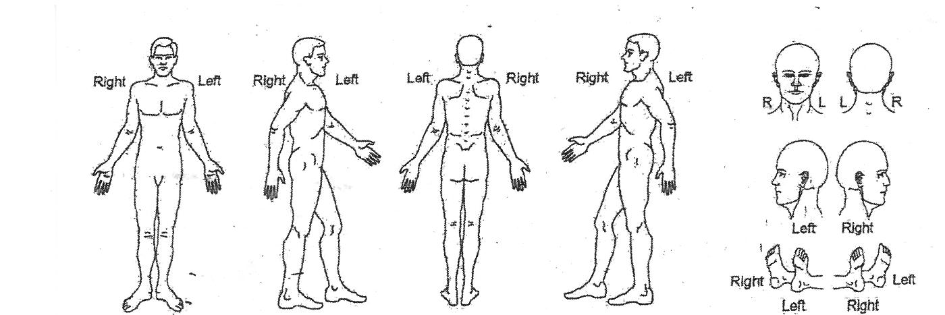
Domestic Situation
With whom do you live? _____________________________________________________________________________
Are there any substance abuse issues in the household? Yes  No
If yes, please explain: _______________________________________________________________________________

Are you able to take care of yourself? Yes  No
If not, please explain: _______________________________________________________________________________

Work History
Employer: _____________________________ What type of work do you do? ______________________________
How many years? ______________________________

Legal Matters
Are you presently involved in a lawsuit? Yes  No
If yes, please explain: _______________________________________________________________________________

Substance Abuse

IN THE PAST, which of the following drugs or substances, if any, have you used?
Please use “N” for Never, “O” for Occasionally and “F” for Frequently.
Alcohol: N O F | Barbituates: N O F | Cocaine: N O F
Heroin: N O F | Amphetamines: N O F | Marijuana: N O F
Other (please specify): ______________________________

AT THE PRESENT, which of the following drugs or substances, if any, are you using?
Alcohol: N O F | Barbituates: N O F | Cocaine: N O F
Heroin: N O F | Amphetamines: N O F | Marijuana: N O F
Other (please specify): ______________________________

Do you presently smoke cigarettes? Yes  No If not, did you EVER smoke cigarettes? Yes  No
How many packs do (did) you smoker per day? _____ For how many years? _____

