Food Cues
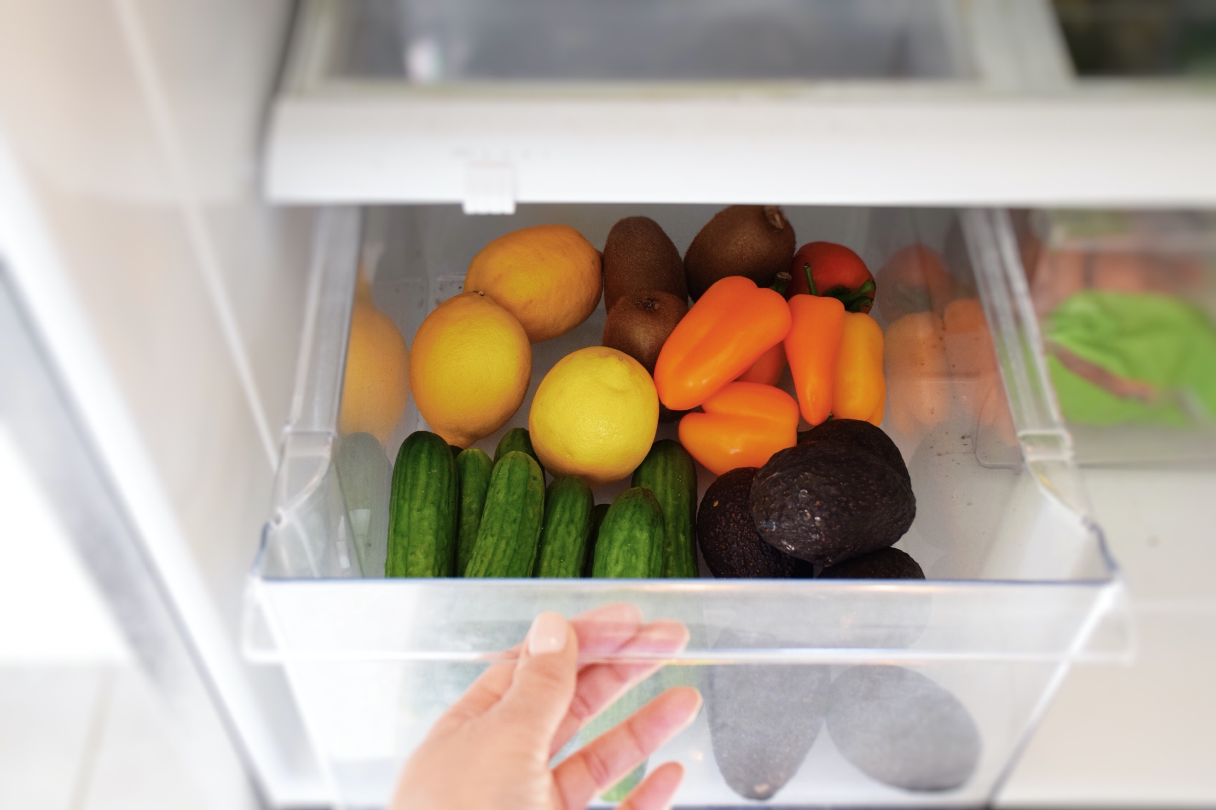
https://www.twenty20.com/photos/bf2d2344-03ef-4dfc-ac47-0d2e946509d6/?utm_t20_channel=bl

How often do you pay attention to food cues? Do you understand what causes you to reach for a snack or a second portion of dinner? Food cues are any kind of stimuli that trigger a food-related response and can include “viewing or smelling of food stimuli, advertisements, or any cues or situations associated with food-related memories.” For instance, this would include a fast food commercial that plays during your favorite television show at night and encourages you to order up some French fries and a cheeseburger for delivery. Food cues, when listened to over hunger cues, can put you at risk of developing obesity.

Mindless Eating
Food cues cue you to eat whether or not you are actually hungry. This encourages mindless eating behaviors. Because you aren’t hungry and you aren’t really paying attention to how much you are eating, mindless eating is associated with weight gain. If you are wondering why you can’t seem to be losing weight when you follow a healthy diet and exercise regularly, excessive snacking due to food cues may be the culprit.

Awareness—Four Types of Food Cues
Food cues present themselves in a variety of ways, and it’s important to understand how they present themselves so you can get to the heart of what triggers you to eat when you aren’t hungry. Cues may be visual, auditory, olfactory, or mental. A visual cue could be a picture of a delicious meal or a commercial for a restaurant. Auditory cues are anything you may hear related to food, whether it’s the sound of bacon frying or coffee percolating. Olfactory cues come into play when you smell food. Mental cues often have to do with your emotions. You may be cued to eat because you are stressed, bored, sad, or feeling out of control. Food cues are quite literally everywhere. You can’t watch television without seeing them and every time your coworker orders takeout, you’re cued too.

Make a list of the food cues that impact you the most. For instance, perhaps you aren’t impacted by olfactory cues, but a picture of food makes you salivate. If mental food cues affect you the most, determine which emotion triggers you the most. Do you grab a candy bar when you’re sad and stressed? Does boredom send you running to the kitchen? Understanding the emotional that cues you can help you overcome that response.

Ignore the External
It’s important to understand that food cues are predominantly external. Instead of listening to external stimuli that tells you when to eat, pay attention the internal hunger response. That may be a growling stomach, hunger pangs, or lightheadedness and tiredness associated with lack of food. Similarly, pay attention to internal cues as you eat so that you can stop eating when you are full. Your brain takes some time to process, so eat slowly.

Once you are aware of what is cueing you, take some time to think about whether or not you’re truly hungry, or if you’re just responding to an advertisement. Give it a few minutes; oftentimes, if you do not indulge your craving immediately, it will go away. Drink some water and distract yourself with another activity to take your mind off the food cue response.

For tips on mindful eating, check out our blog.

©2021 ReShape Lifesciences Inc All Rights Reserved Part Number 04-0769 Rev A

Meta Description: Food cues are everywhere, and they may be causing you to overweight and gain excess weight. Read our blog to learn how to fight food cues.

