Tips for Staying Hydrated After the Lap-Band® Procedure

Meta Description | Staying hydrated can be difficult. If you’re a recent Lap-Band patient or just beginning your weight-loss journey, try these tips for staying hydrated.
Keywords | Hydration and weight loss, importance of hydration during weight loss, how to stay hydrated, hydration tips, drinking water weight loss,
Alt Tags | Woman holding out a full glass of water
 | 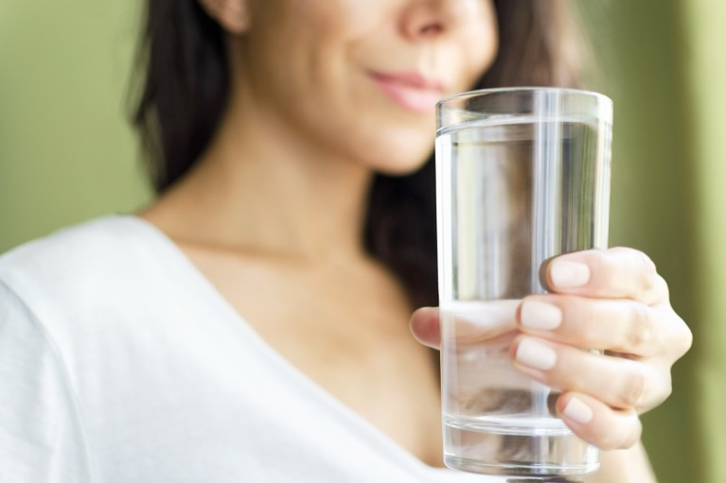
Image Link | https://www.twenty20.com/photos/c9d83d72-fe96-432c-9c18-6ea3a8950697

Drinking enough water should be a priority for everyone, but for people who’ve had weight-loss surgery, like the Lap-Band® Procedure, hydration is especially important. Dehydration is one of the most common reasons bariatric patients return to the hospital after their surgery. However, getting the proper amount of water can be difficult for bariatric patients who are still adjusting to their smaller stomach size and new eating habits. Whether you’re a recent Lap-Band patient or just beginning your weight-loss journey, try these tips for staying hydrated.

How Dehydration Affects Your Health and Weight Loss

Not only can dehydration negatively affect your health, but drinking the proper amount of water can actually aid in your weight loss. Dehydration leads to fatigue, leaving you with less energy to exercise and making you more likely to make unhealthy food choices. Water is instrumental in almost every bodily function, including metabolizing food. Low water levels means your digestion rate is slowed, which can increase your difficulty in losing weight.

Water acts as a natural appetite suppressant, causing the feeling of fullness. Hunger and thirst also feel very similar, so before you reach for a snack, try drinking a glass of water to see if it reduces your hunger.

Staying Hydrated After the Lap-Band Procedure

During the Lap-Band procedure, an adjustable gastric band is placed around the upper section of the stomach. This creates a small pouch that can hold a limited amount of food and fluid, helping you control your feelings of hunger. While the Lap-Band does lead to lasting, sustainable weight loss, it will also require you to make some adjustments to stay properly hydrated.

Sip, Don’t Chug
Drinking too fast and too much at once can cause nausea and vomiting after your weight-loss surgery. Instead, aim to sip your water throughout the day. If this isn’t a habit for you, try using a hydration tracker app or timer to remind you to meet your goals.

Don’t Drink with Meals
To avoid over-filling your stomach pouch, avoid drinking 30 minutes before and after your meals. This also helps prevent washing food through your stomach pouch.

Avoid Dehydrating and Carbonated Drinks
Try to avoid dehydrating drinks like coffee, caffeinated soda, and alcohol. If you want variety in your fluids, try adding fruit to your water for some extra flavor. Steer clear of carbonated drinks, too—all those bubbles can cause bloating and stomach discomfort.

Know the Signs of Dehydration
One of the most important tips for staying hydrated after starting the Lap-Band Program: know the signs of dehydration.

- Extreme thirst
- Dizziness
- Fatigue
- Dark yellow urine
- Light-headedness or headache
- Dry lips and mouth
- Confusion
- Elevated pulse
- Infrequent urination

Of course, you shouldn’t wait until you notice these signs to drink water, but knowing the symptoms can help you prevent your dehydration from getting worse.

Looking for more tips for success after your Lap-Band procedure? Visit our website for all the resources you need to get on track to a healthier lifestyle.

