The Importance of Hydration

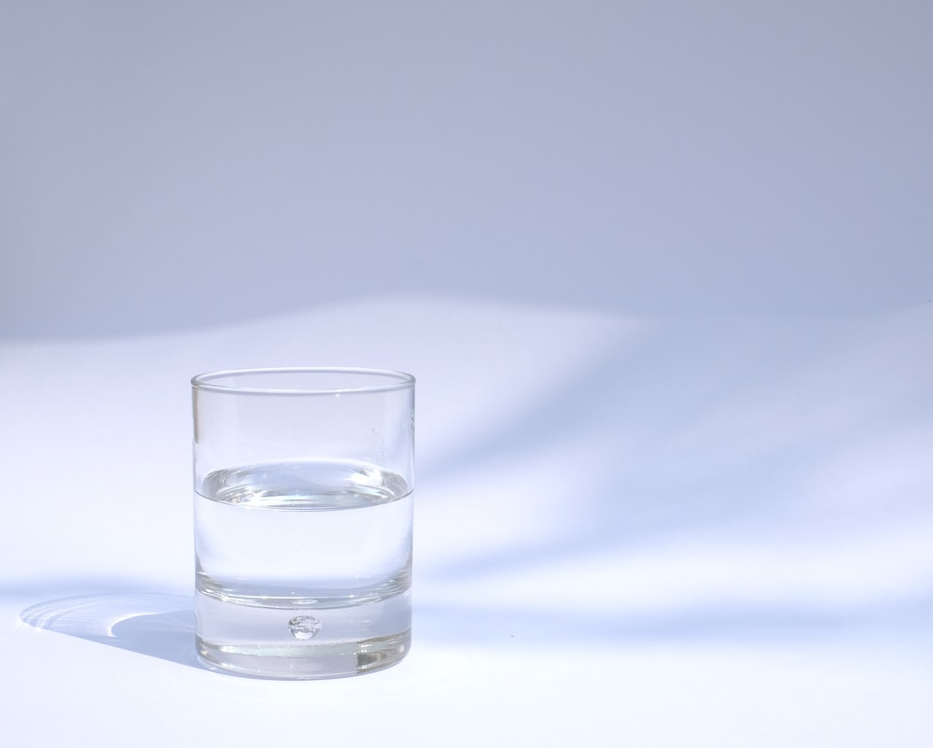
https://images.unsplash.com/photo-1534616042650-80f5c9b61f09?ixlib=rb-1.2.1&ixid=eyJhcHBfaWQiOjEyMDd9&auto=format&fit=crop&w=925&q=80

Staying hydrated is especially important during the summer months, when it’s excessively hot and much easier to become dehydrated. If you have just had the Lap-Band® Surgery, it is even more crucial to stay hydrated. Some people can be hospitalized following bariatric surgery due to dehydration. It’s important to know the signs of dehydration and to develop strong habits of hydrating regularly.

Understanding how much water your body needs is not one-size-fits-all as was previously believed, but a good number to aspire to is eight glasses of water per day. How much water you drink per day depends on a few factors, including your weight, any health conditions that can make too much water a problem, and any medications you may be on that can cause you to retain water. A good rule of thumb is to divide your body weight by two and then drink that number of ounces of water per day. For instance, if you weigh 150 pounds, you would need to drink 75 ounces of water per day.
If you want your body to function properly, you need to drink a lot of water. Staying hydrated is also an important part of the weight loss process. Staying hydrated improves your digestion, helps flush the system, and reduces fluid retention. Water is a necessary part of the food metabolizing process, which includes burning fat. Water also acts as a natural appetite suppressant, so sometimes if you feel hungry, you may actually just be thirsty and a glass of water will be enough to satiate you.

You may find it difficult after Lap-Band surgery to get your recommended daily ounces of water, as your stomach pouch is smaller. The process may a hard adjustment at first, but you will become accustomed to this. It is important that you do not drink fluids that will dehydrate you further, like caffeinated drinks or alcohol. Any carbonated drinks may also be an issue after Lap-Band Surgery or other bariatric surgeries. They could cause gas, bloating, nausea, and other stomach discomfort. These beverages can also have hidden sugar and calories, which can cause you to gain weight or plateau.

It’s far too easy to go throughout the day without thinking about how much water you’ve consumed, so track your consumption with an app or set a reminder on your phone to drink water at regular intervals. Make sure you also carry a reusable water bottle with you so that you can refill it regularly.

©2020 ReShape Lifesciences Inc All Rights Reserved Part Number 04-0597 Rev A

