Setting Attainable New Year’s Goals

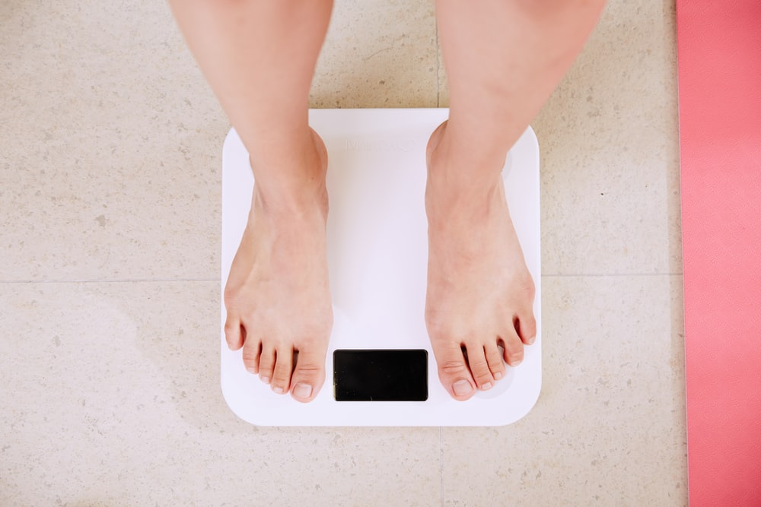
https://images.unsplash.com/photo-1522844990619-4951c40f7eda?ixlib=rb-1.2.1&ixid=eyJhcHBfaWQiOjEyMDd9&auto=format&fit=crop&w=1350&q=80

Many individuals make New Year’s resolutions to lose weight. While there’s nothing wrong with that, many people make unrealistic, drastic weight loss goals. These unrealistic weight loss resolutions can end up being damaging to your mental health and can set you back. It’s better to set more positive, health-centered New Year’s Resolutions that are easier to reach.

Losing weight, especially after having bariatric surgery, is an understandable resolution to make. However, the best way to lose weight with the LAP-BAND® is not drastically, but slowly and steadily. Rather than making a goal of seeing a specific number on the scale, focus on healthy behaviors. Chances are, incorporating these healthy behaviors will help you naturally lose weight.

Work up to a Fitness Goal
If you’ve never been a runner, but you make a resolution to run a half marathon by the spring, you may be setting yourself up to fail. Instead, consider making a more attainable goal. Work up toward a 5K by the end of the year. Make it a goal to do 25 push-ups in proper form. Aim to increase your flexibility, and define what that means to you. Maybe you just want to be able to touch your toes, or maybe there’s a tough yoga pose you’re hoping to land. Maybe you’ll reach your goal before the end of the year, and that’s okay. Just make another one.

Eat Mindfully
Practicing mindful eating is a great New Year’s Resolution. The practice is definitely beneficial after having the LAP-BAND Procedure. Listen to what your body is telling you. Eat slowly, and focus on the flavors and textures you’re experiencing. Chew your food thoroughly. Eating shouldn’t be a race. Take your time so that your stomach and brain are on the same page and you can quit eating when you’re full. Mindful eating is a great way to prevent you from overeating, which in turn will help you naturally lose weight.

Skip the Fad Diets
Because many people want to lose weight quickly, they resort to fad diets. Don’t do that. They can be tough on your body, and oftentimes they aren’t all that healthy in the first place. They can cause you to self-sabotage and gain more weight in the end. Small changes make all the difference. Resolve to make small, healthy changes to your diet and continue to adapt as each small change becomes habit. Your LAP-BAND support group will be able to help you with appropriate dietary choices.

It’s important to remember that any sort of lofty resolution can both be damaging to your mental health and your physical health. Drastic resolutions, such as deciding to work out every single day when you normally never exercise, can cause you to burnout and give up your resolution by February. Small changes and consistency are key.

©2019 ReShape Lifesciences Inc All Rights Reserved Part Number 04-0543 Rev. A

