Eating During the Holidays with your LAP-BAND

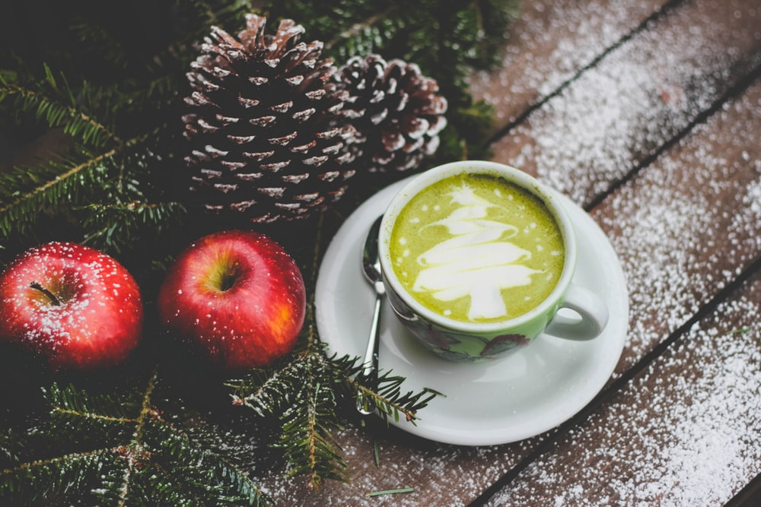
https://images.unsplash.com/photo-1512484149279-9751676e56c4?ixlib=rb-1.2.1&ixid=eyJhcHBfaWQiOjEyMDd9&auto=format&fit=crop&w=1350&q=80

The holidays can be an incredibly difficult time for individuals trying to follow a healthy lifestyle. Temptations are in every direction—cookies, special holiday drinks like peppermint mochas and eggnog, side dishes like mashed potatoes and gravy and stuffing, and boxes of candy brought to the office by colleagues and clients. Slipping up might feel inevitable. Not only may you struggle to follow your eating plan, there’s a good chance you might be struggling to get enough exercise in. It is especially important to eat well after the LAP-BAND® Procedure.

Stay Hydrated
Staying hydrated is important for overall health, but it is especially crucial with the LAP-BAND. Not only should you stick with water because it is free of calories and sugar, unlike holiday drinks, but it will help you digest your food effectively. It will also help you maintain feelings of fullness. Be sure you drink a glass of water before you begin any holiday meal. It may turn out that you aren’t as hungry as you anticipated, but were simply thirsty.

Plan Meals Accordingly
If you know you’re going to be at a party or meal with lots of fattening and calorie-laden foods, come prepared with your own healthy options. Arm yourself with healthy, on-plan foods that you can feel good about enjoying while still enjoying yourself. If you do decide to eat the prepared meal, remember to fill up on vegetables first. Skip the vegetables coated in butter and sauce, and opt for steamed or fresh vegetables. If you’re cooking the meal, show your family how good healthy recipes can be by preparing meals with minimal butter, cream, and fattening sauces. And remember, if you’re waiting for the meal to start, don’t stand by the food table; you’ll be prone to snack. Pop a stick of sugar-free gum if need be.

Be Mindful
Be mindful when you are eating. Chew slowly and mindfully. Enjoy each bite. Not only will the experience be more enjoyable, but you will be able to pay attention to hunger cues more easily. If you eat too quickly, it is easy to overeat because your stomach doesn’t recognize how full you are. It also helps if you aren’t starving when you start the meal.

Be mindful when you are in grocery stores as well. There are special holiday foods around every corner. Before you pick up those goodies, think about how the foods will make you feel. Is it nutritional? Will you feel good after you eat it? Don’t go to the store hungry, either. You’ll be more prone to impulse buy.

Grab your Walking Shoes
Bring your walking shoes with to the holiday party. Suggest a walk before or after the meal. Going for a slow walk after dinner is a great way to promote digestion.

The holidays aren’t all about the food. They’re about enjoying festive cheer with family and friends; put the focus on that and you’ll be good to go.

©2019 ReShape Lifesciences Inc All Rights Reserved Part Number – 04-0538 Rev. A

