Breast Cancer and Obesity
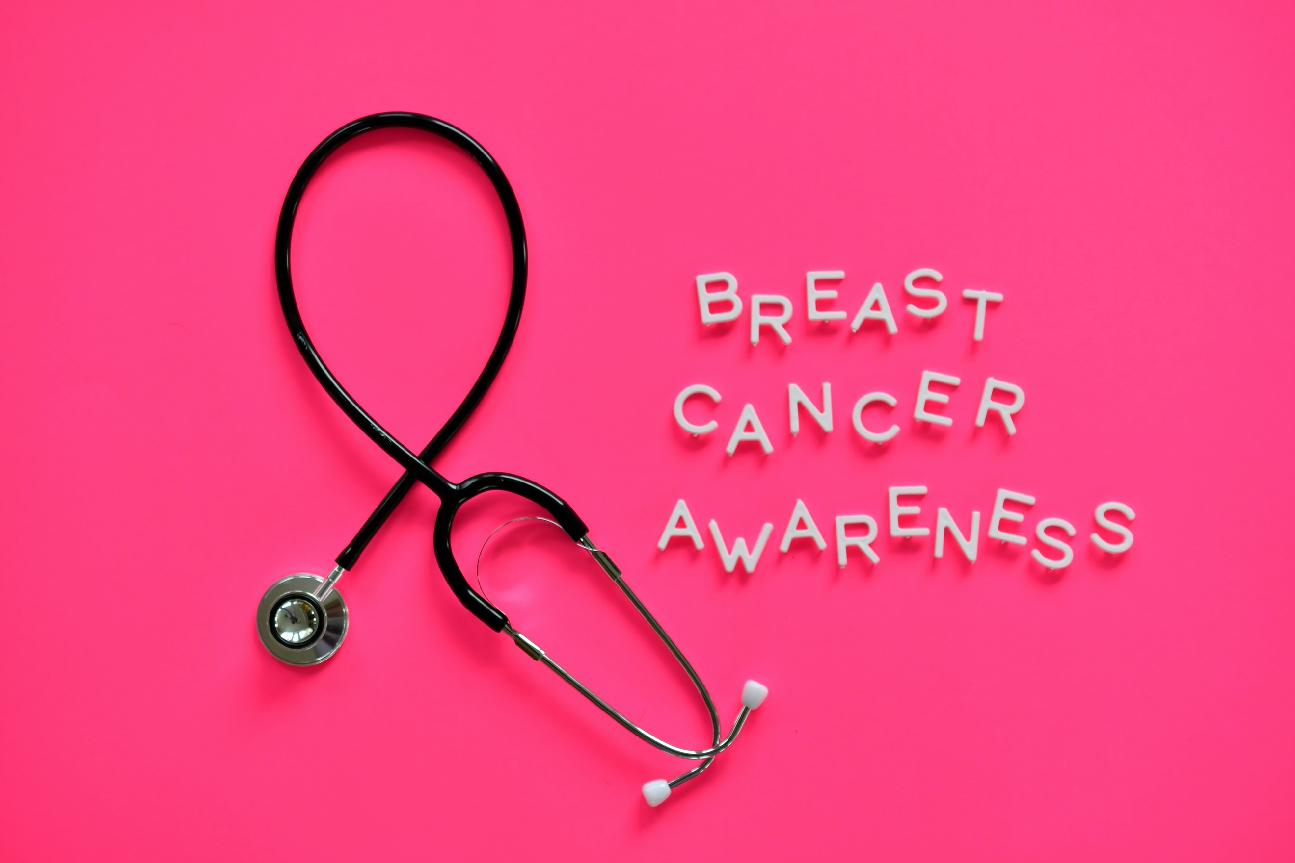
https://www.twenty20.com/photos/021ecfa5-0a58-42d6-9393-5e702dc48cde/?utm_t20_channel=bl

The Centers for Disease Control and Prevention (CDC) says that approximately 42.4% of the American adult population is obese. Does obesity increase your risk for breast cancer? Obesity can make the risk of certain medical conditions increase, such as heart disease, type 2 diabetes, strokes, and some cancers. Unfortunately, obesity is linked to a higher risk of getting breast cancer.

High Estrogen Levels
Women who are overweight or obese after menopause have an increased risk of breast cancer. Menopause typically happens in a woman’s forties or fifties, occurring after a woman has her last menstrual cycle. Menopause is marked by the decline in reproductive hormones. The ovaries stop producing the hormone estrogen, which means the remaining estrogen in the body comes from fat tissue. The more fat tissue in the body following menopause, the higher the estrogen levels. A woman with obesity is also more likely to have a high level of insulin in her body, which has been linked to breast cancer.

Unclear Research
However, the link between breast cancer is not clear-cut, and experts still have a lot of questions to answer. For instance, some research shows that women who have struggled with being overweight since childhood may not share the increased breast cancer risk that women who gain weight after menopause have. Additionally, certain types of breast cancer, such as hormone receptor-positive breast cancer, may be more likely than other types depending on weight gained after menopause versus before.

Breast Cancer Risk Factors
Given how complicated the link between obesity and breast cancer is, it’s important to understand the other risk factors for breast cancer. Experts do still suggest that obesity is linked to breast cancer, so avoiding weight gain is important. Consuming even one alcoholic drink per day is linked to breast cancer, while the risk of developing breast cancer increases as the drinks per day increase. Some forms of birth control and hormone therapy following menopause can increase the risk of breast cancer too. Still, the most important link appears to be physical activity. A sedentary lifestyle can increase breast cancer risk in women, so experts recommend that women hoping to reduce their risk of breast cancer should exercise regularly.

October is Breast Cancer Awareness Month. To review the risk and symptoms of breast cancer, visit: https://www.nationalbreastcancer.org/breast-cancer-awareness-month. If you are concerned about your risk for breast cancer, talk to your doctor.

©2020 ReShape Lifesciences Inc All Rights Reserved Part Number 04-0688 Rev A

