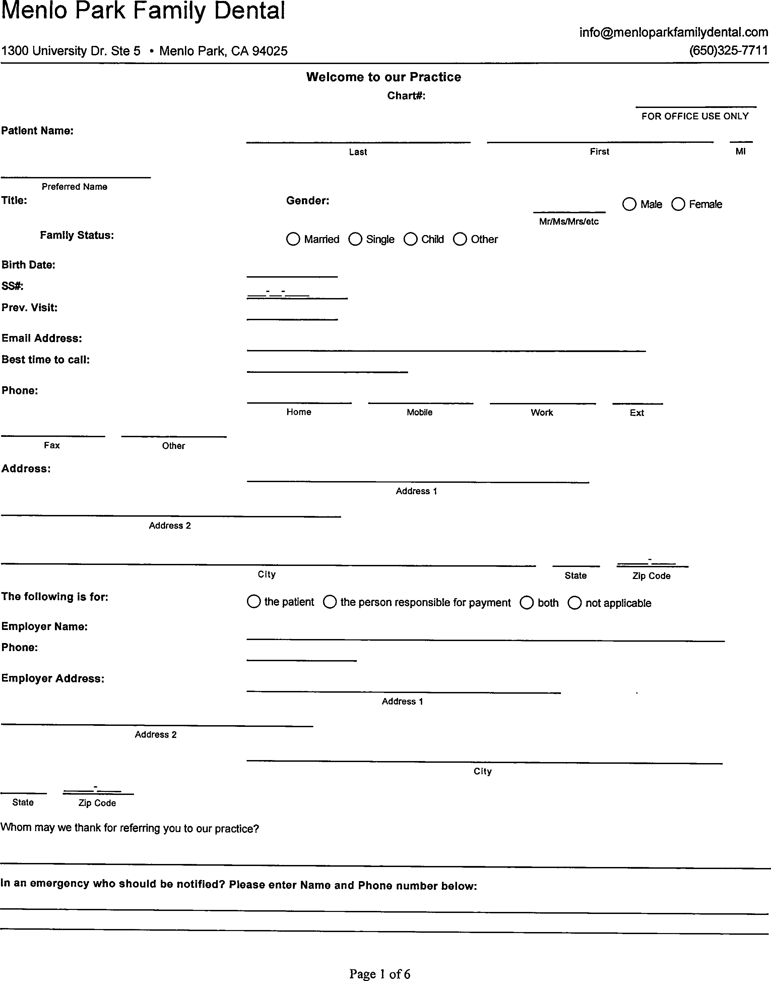

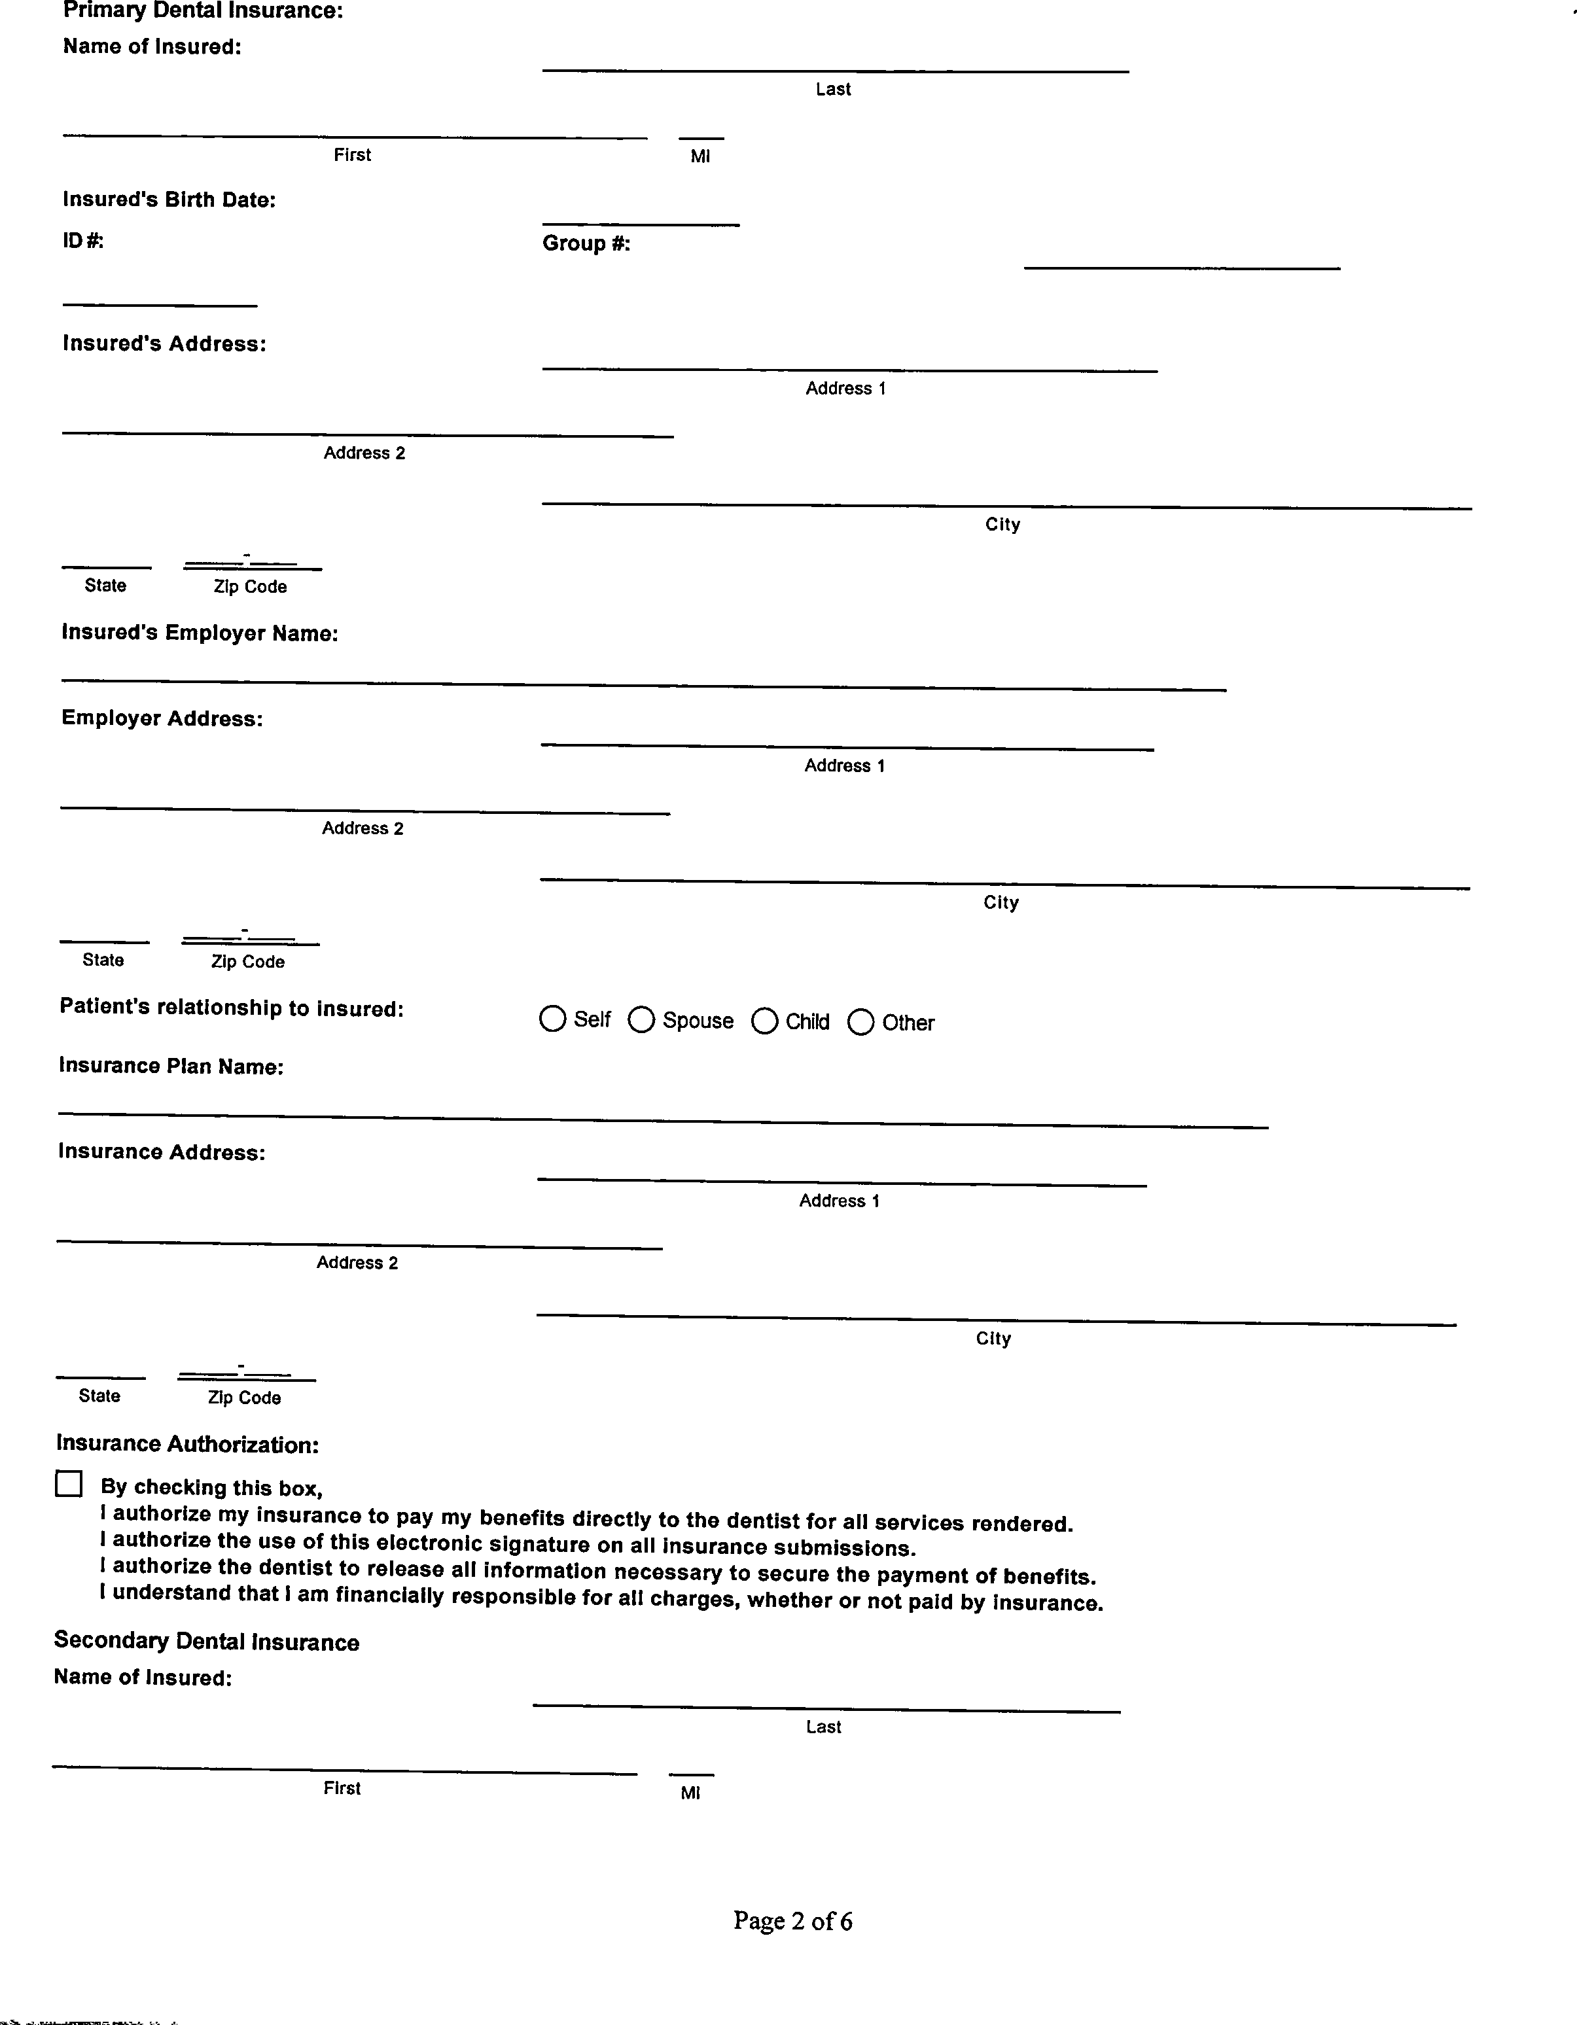

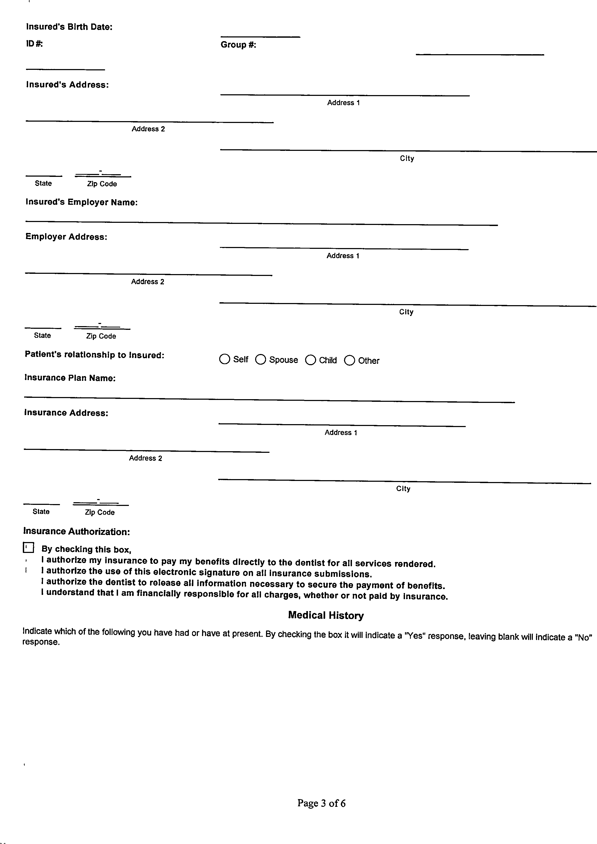

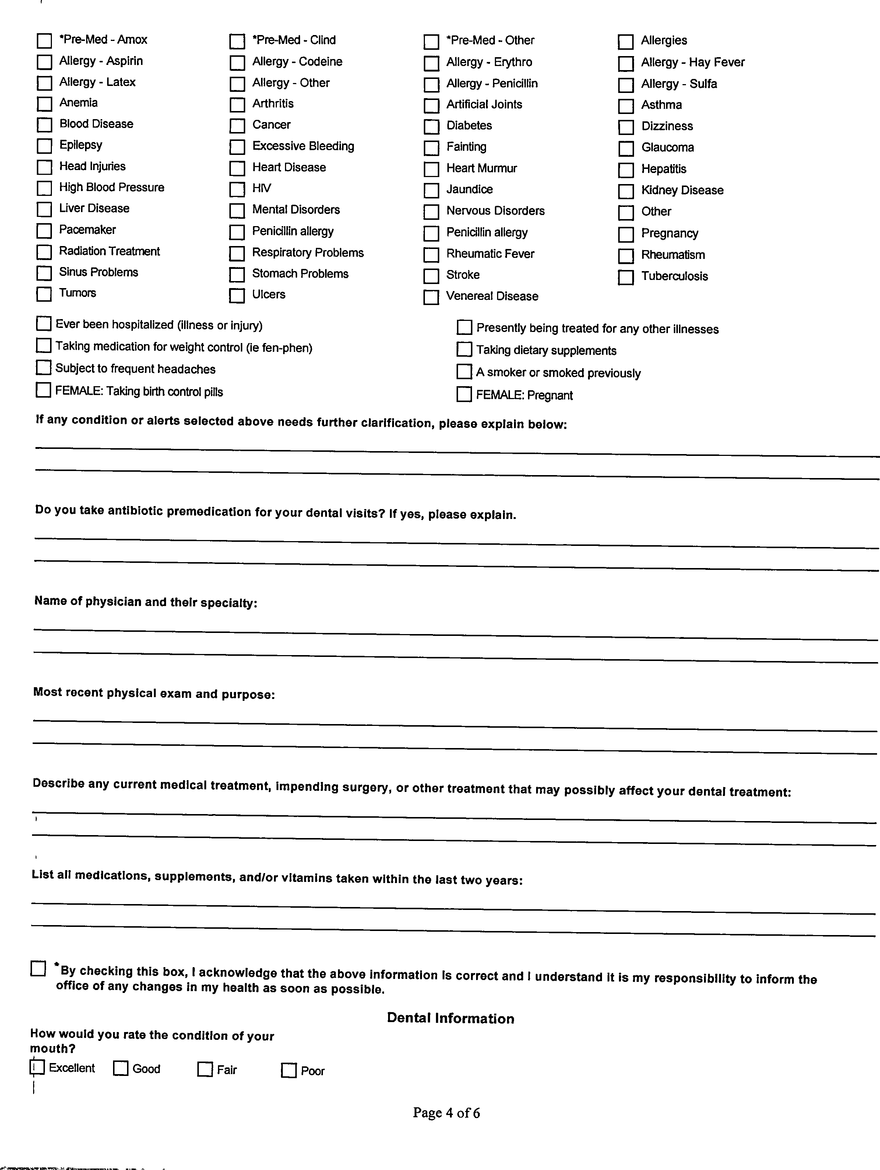

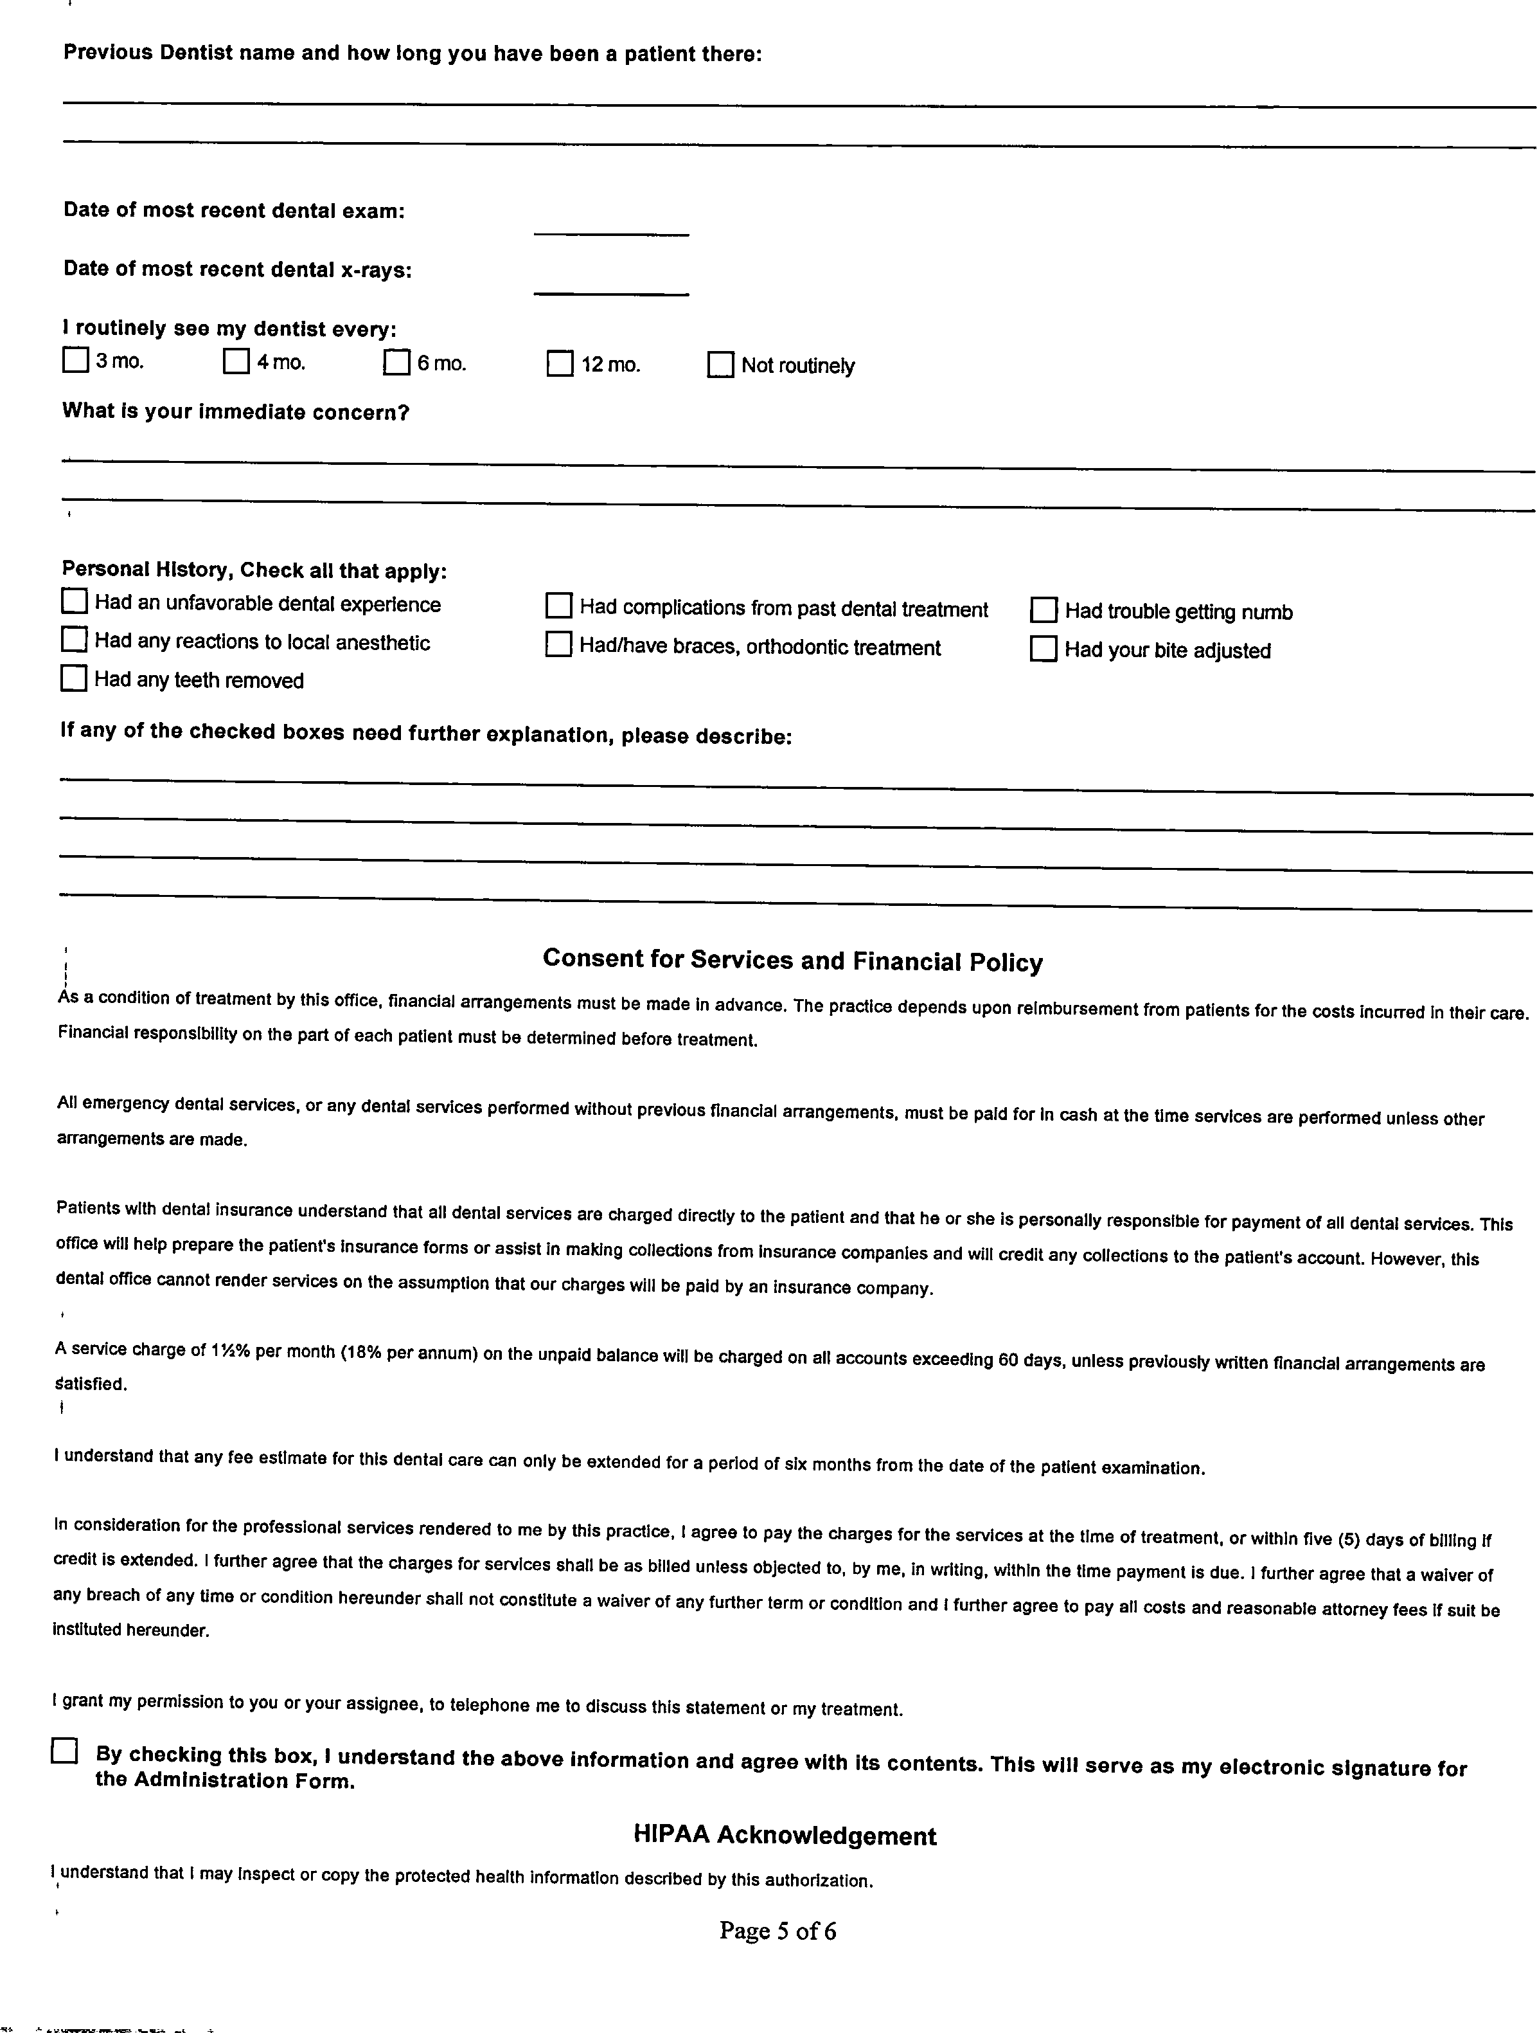

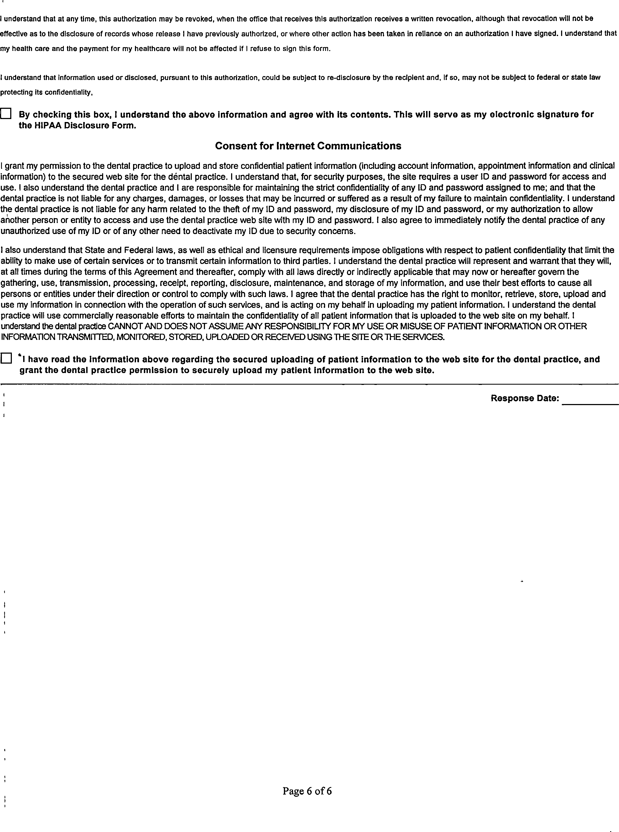

RELEASE AUTHORIZING USE OF PERSONAL LIKENESS

I, (patient name) consent to the use of my personal image and likeness, including but not limited to images representing and depicting the treatment provided to me and the effect thereof, by Menlo Park Family Dental for any lawful use Menlo Park Family Dental deems appropriate, including for treatment, advertising his/her/its services to the general public (including via social media and electronic media), illustration, and publication to the public at large for educational purposes.

I hereby relinquish any and all rights to my likeness or any image of me obtained by any photographic or digital means by Menlo Park Family Dental during the course of my treatment. I understand that I am entitled to no consideration, remuneration or payment for the use of my image in any advertising, promotional or educational materials.

I understand any image or likeness of me may be altered prior to use if deemed appropriate by Menlo Park Family Dental. I understand and agree that I have no right to be consulted about or approve of any such alterations before my image is used.

I understand that Menlo Park Family Dental will make all reasonable efforts to safeguard my privacy as required by applicable law, including the Health Insurance Portability and Accountability Act of 1996 (HIPAA). I understand, however, that Menlo Park Family Dental cannot guarantee my complete privacy in the event my image or likeness is used by third parties.

I understand and agree that Menlo Park Family Dental may use information regarding my health condition, including information regarding my diagnosis, course of treatment, my date of birth and/or age and my other relevant medical conditions, in describing the treatment rendered to me as depicted in any image of me.

I understand that Menlo Park Family Dental may not and has not conditioned the rendition of treatment to me upon my authorization of the use of my image and/or likeness.

I have read the foregoing in its entirety and understand its terms.

Patient/Guardian name

Patient/Guardian signature

Date

Release of Records

Date:

To: (Doctor/Practice)

Address:

City: State: Zip:

Phone: Fax:

I authorize and request the release of my dental x-rays and records, or copies of such, to be transferred to:

Menlo Park Family Dental 1300 University Drive, Suite 5 Menlo Park, CA, 94025
Email: info@menloparkfamilydental.com

Print Name of Patient: DOB:

Signature: (patient, parent, or guardian)

