Injection Guide
A subcutaneous (SubQ) injection, delivers medication into the subcutaneous layer of tissue (fat layer) that is directly under the skin. Medication delivered this way is more slowly absorbed into the bloodstream than medication that is directly injected into the muscle.

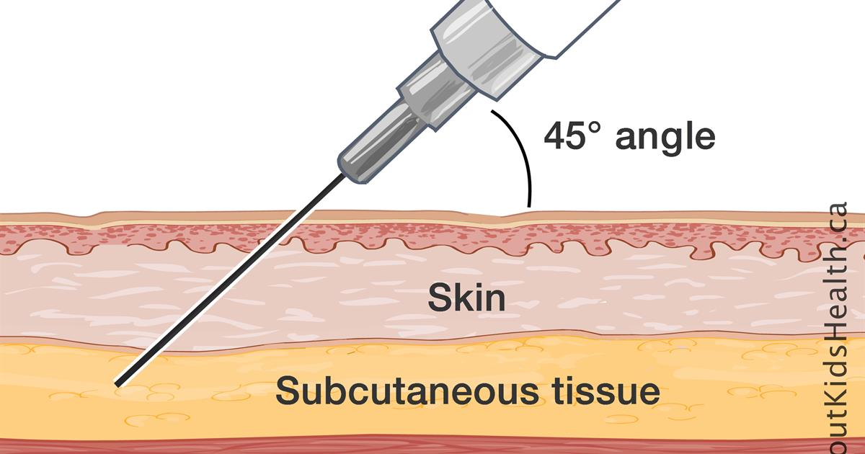

Needles for SubQ injections are usually 25-26 Gauge and 5/8” (inch) in length. Use a separate drawing up needle.

NEVER REUSE OR SHARE SYRINGES OR NEEDLES.
If you need needles or syringes and cannot afford to get them from your doctor or pharmacy, please visit a local needle exchange program:
Any Positive Change (APC) Program, Grand Forks
Cass Public Health, Fargo
Custer Health, Mandan

Step 1
Setting Up for the Injection:
Find a comfortable, well-lit working place.
Check the expiration date on the medication vial. Do not use a medication with visible particles, that is discolored, or is expired.
Wash your hands. Hand washing is one of the most important things you can do to prevent infection.

Step 2
Preparing the Injection Dose
Take the cap off the vial. Clean the rubber stopper with one alcohol swab, and then allow it to air dry.
Check the package containing the syringe. If the package has been opened or damaged, do not use the syringe. • Pull the 18 G needle cover straight off the syringe. Then, pull back the plunger and draw air into the syringe. The amount of air drawn into the syringe should be the same amount (mL) as the dose of medication that your doctor prescribed. Do not let the needle touch any surfaces.
Insert the needle straight down through the center of the rubber stopper into the bottle.
Push the plunger of the syringe down and push the air from the syringe into the vial. • Keeping the needle in the vial, turn the vial upside down. • Position the needle so the liquid is covering the tip of the needle.
Keeping the vial upside down, slowly pull back on the plunger to fill the syringe with the medication to the number (mL) that matches the dose your doctor ordered.
Keeping the needle in the vial, check for air bubbles in the syringe. If there are air bubbles, gently tap the syringe with your fingers until the air bubbles rise to the top of the syringe. Then slowly push the plunger up to force the air bubbles out of the syringe without removing the needle from the bottle. After air bubbles are gone, pull the plunger back to the number (mL) marking on the syringe that matches your dose.
Pull the syringe with needle out of the bottle, remove the 18 G needle (discarding it into the sharps container), and place the smaller subcutaneous injection needle securely on the syringe.
Check to make sure that you have the correct dose in the syringe. It is VERY important that you use the exact dose prescribed by your doctor
Step 3:
Selecting and Preparing the Injection Site
There are several places you can give yourself a subcutaneous injection, including the sides or backs of your arms, the fronts of your thighs, or your abdomen.
Wherever you choose to inject, you should be able to firmly grasp the skin and pinch it up into approximately a 1-inch fold.

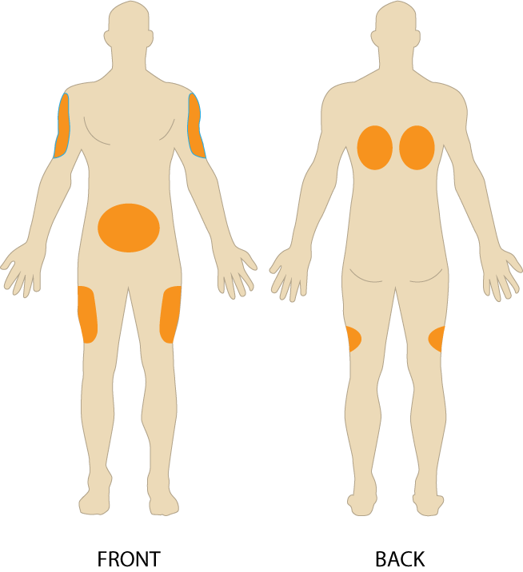

Step 4
Give the injection
Hold the prepared syringe with the hand you will use to give the injection • With the other hand, pinch a fold of skin. (You will inject into the skin between your fingers). • Clean the injection site skin with an alcohol swab; let the skin air dry. • Make certain your hands are clean. • With one quick and firm motion, insert the needle either directly into the skin fold at a 45- 90 degree angle.
Complete the injection by pushing the medicine slowly under your skin. Wait 5 seconds, and then pull back on the syringe to remove the needle from your skin. Dispose of the syringe and needle properly, using a sharps container. You can use a band aid if needed.

Tips for reducing pain:
Never reuse needles ➝ Use separate drawing up and injecting needles ➝ Let the skin dry fully from the alcohol wipe before beginning the injection ➝ Keep the muscles in the injection area warm and relaxed ➝ Inject medicine that is at room temperature ➝ Break through the skin quickly with the needle ➝ Insert the needle straight into the skin, and pull it straight out again without changing direction.

Instructions for Disposing of Sharps:

Put used sharps in a strong, plastic container

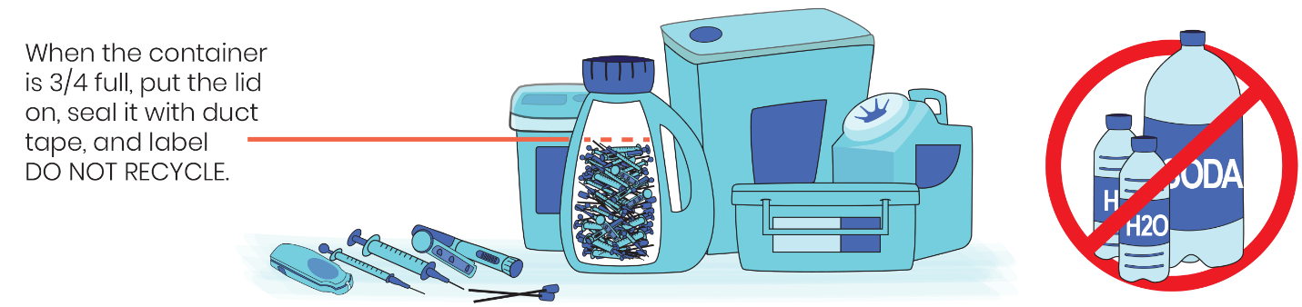

Put the plastic container in the household trash - don't recycle!

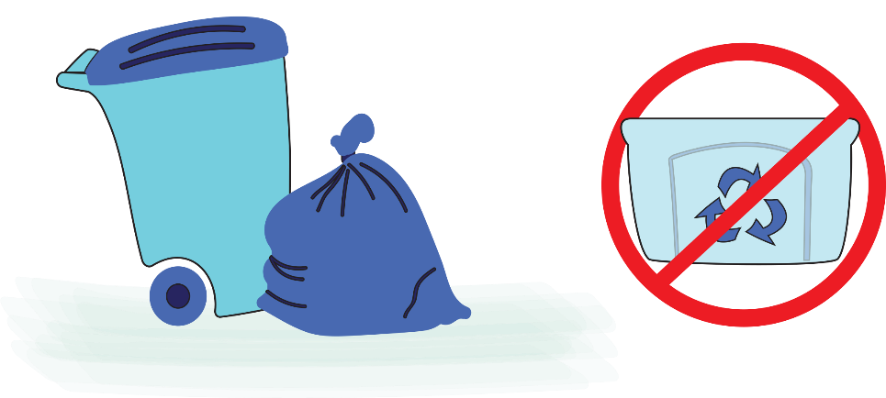

Resources for additional information:

https://www.plannedparenthood.org/planned-parenthood-greater-texas/self-injection-videos

