SOAR SPINE & ORTHOPEDICS
MEDICAL UPDATE FORM
Name:
Pain
Please Rate 0=No Pain 10=Extreme Pain
Right Now: 0 1 2 3 4 5 6 7 8 9 10
At Best: 0 1 2 3 4 5 6 7 8 9 10
At Worst: 0 1 2 3 4 5 6 7 8 9 10
Type of Pain (aching, stabbing, burning, weakness, numbness, etc.):

What makes your pain better?

What makes your pain worse?
Psdafasdfin Location:
Type of pain (ex: aching, stabbing, burning, numbness, tingling, etc.):
Pa
Pain Location:
Type of pain (ex: aching, stabbing, burning, numbness, tingling, etc.):

Pain Location:
Type of pain (ex: aching, stabbing, burning, numbness, tingling, etc.):

Date:
Date of Birth:
MR#:
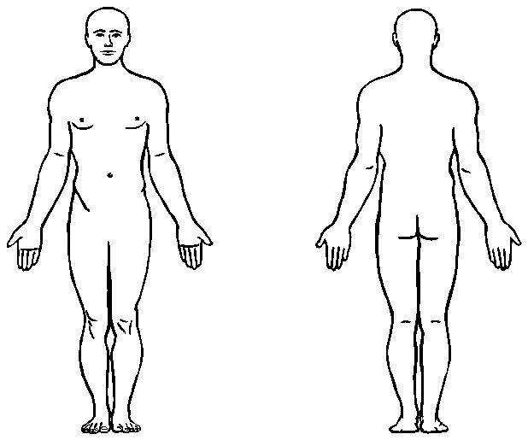
Please mark the body part you are being seen for today

Have you had or are you scheduled for the COVID Vaccine? Yes NO
Any change in your medical history? (Circle one) **IF YES**
Yes No Booster Date: ____________
*If yes please elaborate:

Any change in your medications? (Circle one)
Yes No
*If yes please elaborate:

Since your last visit are you: (circle one) Percent Better or Worse:
Better Worse Same 0 10 20 30 40 50 60 70 80 90 100
Are you currently in Physical Therapy/other Treatment? (Circle one)
Yes No Completed

