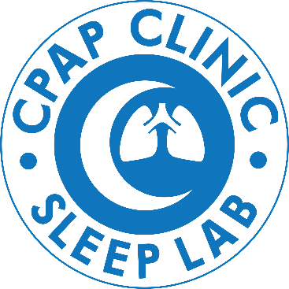

Attention all CPAP Patients!
We heard your feedback and have made changes to the Auto CPAP Supply program.
We are excited to announce our CPAP Supply Membership Program!
The program will include:
- Free Shipping of Quarterly CPAP Supplies
- One free mask per year (up to a $300 value)
- One free CPAP cleaning service per year
Effective Jan 1st 2020 we have improved our Auto Ship program for CPAP equipment. We have eliminated a monthly shipping and processing fee and have enhanced the program to be membership based.
Your yearly membership fee of $60 will be due prior to your first shipment of supplies in 2020. If you chose not to enroll in the CPAP Supply Membership Program, you may order supplies on an “as needed” basis. The shipping charge for orders of Non-Membership equipment will be $12.00 per order.
To ensure there are no interruptions to your current auto CPAP supplies, please contact the office to enroll ASAP. We will send you the membership form to complete along with your credit card information to be charged for the yearly membership fee and for the remaining cost to you, if any, due to your deductible and coinsurance. If you chose to pay out of pocket rather than insurance, or if you do not have insurance, we have self-pay options available as well.
Please contact the office with any question or concerns. We are excited to offer this program to our patients and look forward to providing you the best care and service in 2020!
Sincerely,
CPAP Clinic Staff
Northwest Pulmonary and Sleep Medicine

