High-Fiber Diet: Care Instructions

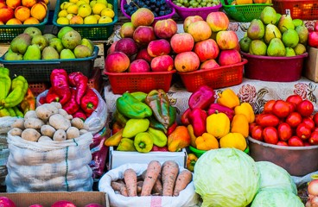

Overview

A high-fiber diet may help you relieve constipation and feel less bloated.
Your doctor and dietitian will help you make a high-fiber eating plan based on your personal needs. The plan will include the things you like to eat. It will also make sure that you get 25 to 35 grams of fiber a day.
Before you make changes to the way you eat, be sure to talk with your doctor or dietitian.

Follow-up care is a key part of your treatment and safety. Be sure to make and go to all appointments, and call your doctor if you are having problems. It's also a good idea to know your test results and keep a list of the medicines you take.

How can you care for yourself at home?

- You can increase how much fiber you get if you eat more of certain foods. These foods include:
  - Whole-grain breads and cereals.
  - Fruits, such as pears, apples, and peaches. Eat the skins and peels if you can.
  - Vegetables, such as broccoli, cabbage, spinach, carrots, asparagus, and squash.
  - Starchy vegetables. These include potatoes with skins, kidney beans, and lima beans.

- Take a fiber supplement every day if your doctor recommends it. Examples are Benefiber, Citrucel, FiberCon, and Metamucil. Ask your doctor how much to take.
- Drink plenty of fluids. If you have kidney, heart, or liver disease and have to limit fluids, talk with your doctor before you increase the amount of fluids you drink.

Where can you learn more?
Go to https://www.healthwise.net/patiented

Enter U654 in the search box to learn more about "High-Fiber Diet: Care Instructions".
Content Version: 13.4

©2006-2022 Healthwise, Incorporated.
This care instruction is for use with your licensed healthcare professional. If you have questions about a medical condition or this instruction, always ask your healthcare professional. Healthwise, Incorporated disclaims any warranty or liability for your use of this information.

