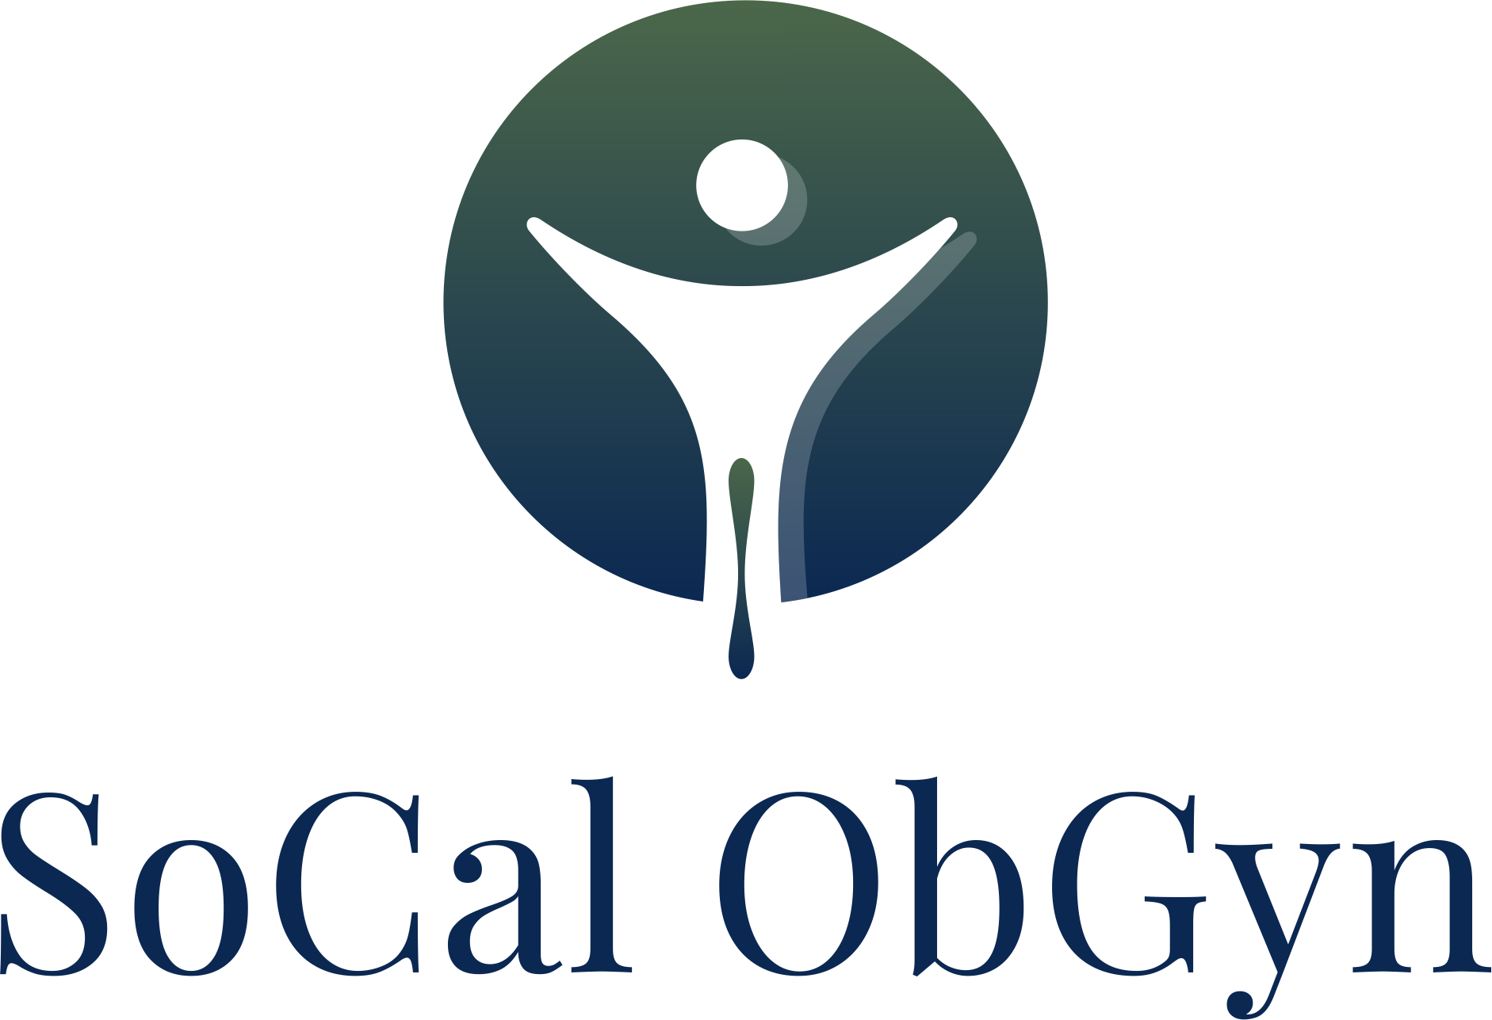

Minal Mehta, M. D. Phone: (714) 848-2383
Hind Al-Azawi, M. D. Fax:(714) 848-4083

18111 Brookhurst Street, Suite 4450, Fountain Valley, CA 92708
========================================================================

DISABILITY FORM POLICY

We require a one-time fee of $25.00 for all disability forms.

I have read the disability form policy and i understand that there is a fee for all disability forms.

______________________________ __________________________
Name Date Of Birth

______________________________ __________________________
Signature Date

