Tips and information for your pregnancy
*** Office Emergency Number 623-846-7597 ***

Having a healthy baby begins with a healthy/happy pregnancy.

Information for a healthy pregnancy:

- Take your vitamins every day unless you are nauseated or take them at night.

- Eat small frequent meals to try to balance a diet. Even if you're not hungry, eat small bits every few hours.

- Eat dry crackers before getting out of bed, wait 10 minutes then move slowly.

- For nausea try ginger ale, ginger cookies, popsicles, mix water and juice & take small sips.

- Try to rest as much as possible.

- Try to exercise a little by walking at a relaxed pace.

First trimester (1-3 months or 1-12 weeks)

- Your breasts become fuller and the area around your nipple becomes darker, breasts become tender.
- You may have morning sickness or nausea and vomiting happen any time during the day.
- Cramping and pelvic pressure may feel like menstrual cramping, If the pain is severe, call us.

At 6 weeks the baby has a beating heart, eyes, limb buds and ½ inch long. By 8 weeks little webbed fingers and toes will have formed. All of the body organ systems are developing. By 12 weeks the fingers and toes have separated and genitals appeared. The baby is 3½ inches long.

Second Trimester (4-6 months or 12-28 weeks)

You may feel the baby move. You may notice a dark line down the center of your abdomen; caused by hormone changes.

- Difficulty with breathing is expected to go slower.
- You may become anemic and need extra iron, take iron with fruit juice and increase fiber to combat constipation.
- Your side may ache when you walk, go up stairs or get out of bed; the uterus growing is stretching ligaments.

At 16 weeks the baby is developing ears, eyelashes and fingernails. His legs are longer and his fingers open and close. He is moving and hair is on his head. He can hear your heartbeat and voice. By 20 weeks he is covered with fine hair (lanugo) and can practice sucking. By now the baby is about 7 inches long. At 24 weeks baby can begin with eye movements. At 28 weeks his skin becomes a little wrinkled and the baby can practice breathing movements. Eyes open and close. Healthy baby born now has a good chance of survival. Baby is about 10 inches long and weighs about 1-1½.

Third Trimester (7-9 months,28 weeks to delivery)

- You may have increased vaginal discharge and milk from the breasts.
- Leg cramps may occur at night, point your toes up towards your tummy, increase calcium intake.
- Lower back pain and sciatic nerve pain; don't twist and bend at the same time
- Swelling feet and ankles drink MORE WATER, elevate your legs.
- Shortness of breath as the baby grows.
- Cut down on salt.

The fine body hair starts to disappear, the brain develops more quickly. At 28 weeks the baby is 14 inches long and weighs about 2 pounds. During this last trimester your baby gains by 34 weeks most babies are in the head down position.

DO’S AND DON’T

- Exercise: Walking, swimming, low impact aerobics. USE COMMON SENSE!
- If it hurts don't do it. If you have been exercising you may continue. If you have not been exercising, start slowly.
- Do not exercise if your doctor has told you not to.
- Sex: Unless your doctor has advised against it, it is safe and does not harm the baby. Do not have sex if you have vagina or abdominal pain, blood or fluid leaking from your vagina.
- Travel: Travel is safe in pregnancy if you are healthy. Try to walk around every 2 hours of travel, whether by car or airplane or on the bus.
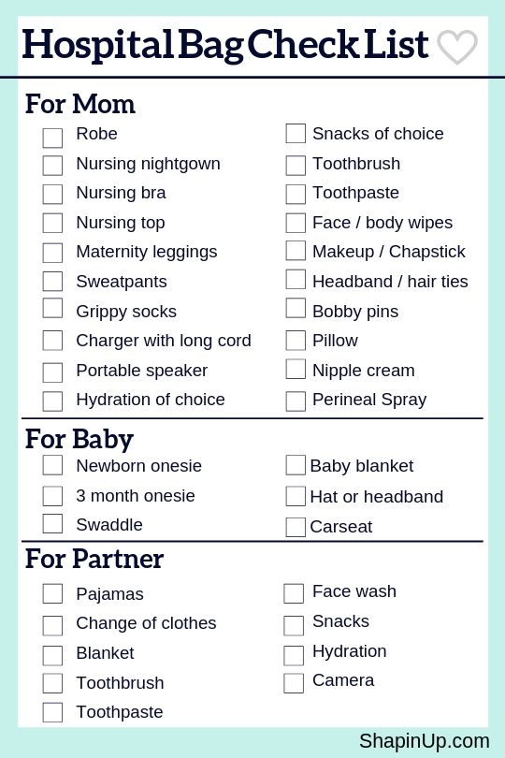
All of the following medications may be purchased over the counter. You do not need a prescription for any of these medications listed. We do not recommend taking any medications during your first trimester (first 14 weeks of pregnancy). Please do not use any substitution or combination drugs without calling our office first at 623-846-7597. If you are given a prescription for a medication please check with your doctor’s office before filling the prescription to make sure that you are able to take the medication during pregnancy.

NAUSEA:

- Emetrol
- Pepto Bismol
- Drammamine
- Mestex

HEARTBURN:

- Tums
- Rolaids
- Gaviscon
- Mylanta
- Maalox
- Ripan
- Gelusil
- Pepto Bismol

CONSTIPATION:

- Citracal
- Metamucil
- Colace
- Milk of Magnesia
- Bran

ALLERGIES:

- Claritin
- Zyrtec
- Allegra

INDIGESTION:

- Zantac
- Pepcid
- Prilosec

HEADACHES, ACHES AND PAINS:

- Tylenol

HEMORRHOIDS:

- Anusol
- Preparation H
- Tronolane Cream

DIARRHEA:

- Imodium
- Kaopectate
- Pepto Bismol

COLDS:

- Any Tylenol Product
- Actifed (Plain)
- Robitussin DM for Cough
- Sudafed (Plain) do NOT use in 3rd Trimester
- Cepacol Lonzenges
- Ocean Nasal Spray
- Ricola
- Ayr Nasal Spray

ITCHING:

- Benadryl Cream

