Andre Nicolas Gay M.D.
Orthopaedic Surgeon & Lower Extremity Reconstruction

Janice Cooper N.P.
Certified Nurse Practitioner

39180 Farwell Drive, Suite 110, Fremont, CA 94538
Phone: 510.739.6520Fax: 510.739.6522

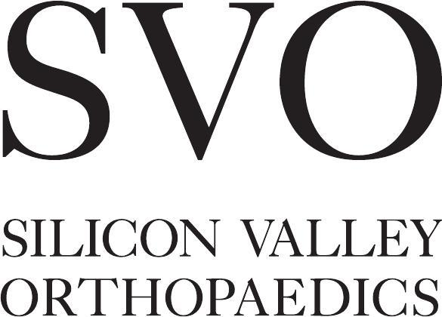

Masi L. Reynolds D.O.
Orthopedic Surgeon Sports Medicine &
Advanced Arthroscopy Joint Preservation

April Mancuso Reynolds D.O
Board Certified Physical Medicine &
Rehabilitation

- k

Date: PT Facility:
Patient Name: ________________________________
Diagnosis:

Visits: times a week for weeks ( visits)
- Evaluation & Treatment □ PROM / AROM Exercises
- Back Rehabilitation Program □ Strengthening Exercises
- Cervical Rehabilitation Program □ Flexibility Exercises
- Knee Rehabilitation Program □ Endurance Training
- Shoulder Rehabilitation Program □ Mobilization
- Elbow Rehabilitation Program □ Gait Training
- Wrist / Hand Rehabilitation Program □ Codman Exercises
- Foot / Ankle Rehabilitation Program □ Work Hardening
- Independent Home Program □ Other:
- Continue Current Therapy Protocol

- Rotator Cuﬀ Repair □ PCL □ PCL / PLRI
- Subacromial Decompression □ HTO
- Shoulder Reconstruction (anterior) □ Lateral Release
- ACL □ Proximal / Distal Protocol
- ACL / Meniscal Repair □ Other:
- ACL / PCL
:

