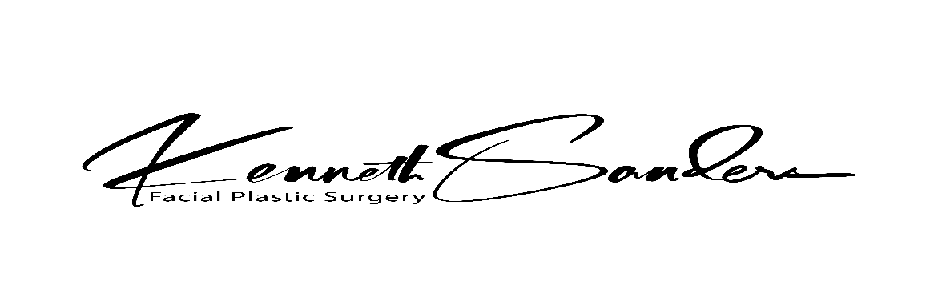

Acknowledgement of the Receipt of the Notice of Privacy Practices

Patient’s Name/Last: First: Middle: SSN:
Residence Address: City: State: Zip:
Mailing Address: (check here if same as above)

Home Telephone #: Cell Telephone #: Email Address:
Date of Birth/Month: Day: Year: Male Race Ethnicity: Hispanic or Latino
Female Non Hispanice or Latino

Employer’s Name: Work Telephone #: Ext.
Language: English Spanish Other: ______________ Marital Status: SINGLE MARRIED WIDOWED DIVORCED
Communications Needs: _____________________________
RESPONSIBLE PARTY (check here if same as above)
Name/Last: First: Middle: Responsible Party’s SSN: Date of Birth :
Mailing Address: City: State: Zip:
Home Telephone: Relationship to Patient:
Employer’s Name: Work Telephone #:
Responsible Party’s Spouse’s Name (if applicable): SSN:
In Case of an Emergency, who may we notify (other than someone living with you) Relationship to Patient:
Name: Telephone Number:
Address: City: State: Zip:
Who referred you to our office? Telephone Number:
Kenneth W. Sanders, M.D. Facial Plastic Surgery (and our Medical Staff) will use and disclose your personal health information to treat you, to receive payment for the care we provide and for other health care operations. Health care operations generally include those activities we perform to improve the quality care. We have prepared a detailed NOTICE OF PRIVACY PRACTICES to help you better understand our policies in regards to your personal health information. The terms of the notice may change with time and we will always post the current notice at our facilities, on our website and have copies available for distribution.
I acknowledge that I have been made aware of the NOTICE OF PRIVACY PRACTICES (copy in waiting room).

______________________________ _______________
Signature of Patient/Guardian Date

______________________________
Patient/Guardian Name-Please Print

