Physician Assistant  - UC Davis School of Medicine PA Program (2001), Nationally Board Certified  - Master of Science Degree (w/Honors) in Exercise Physiology, Cardiopulmonary Pathophysiology – California Polytechnic State University, San Luis Obispo, CA  - Bachelor of Science Degree in Human Biology – California Polytechnic State University, San Luis Obispo, CA  - Former Faculty Member at UC Davis School of Medicine FNP/PA Program – Teacher of the Year (2003)  - Faculty Development Award – University of Washington School of Medicine, Seattle, WA  - 20 Years of Experience, including Family Practice, Urgent Care, Cardiology, Hospital Medicine, Pediatrics, Women’s Health, Weight Loss, Public Health/Indigent Care  - Volunteer Disaster Relief Work – International Medical Corps., Kashmir, Pakistan (Earthquake, 2005)  - National Registry of Certified Medical Examiners -DMV Physicals (NRCME #5900838660)  - Certified CrossFit Trainer | 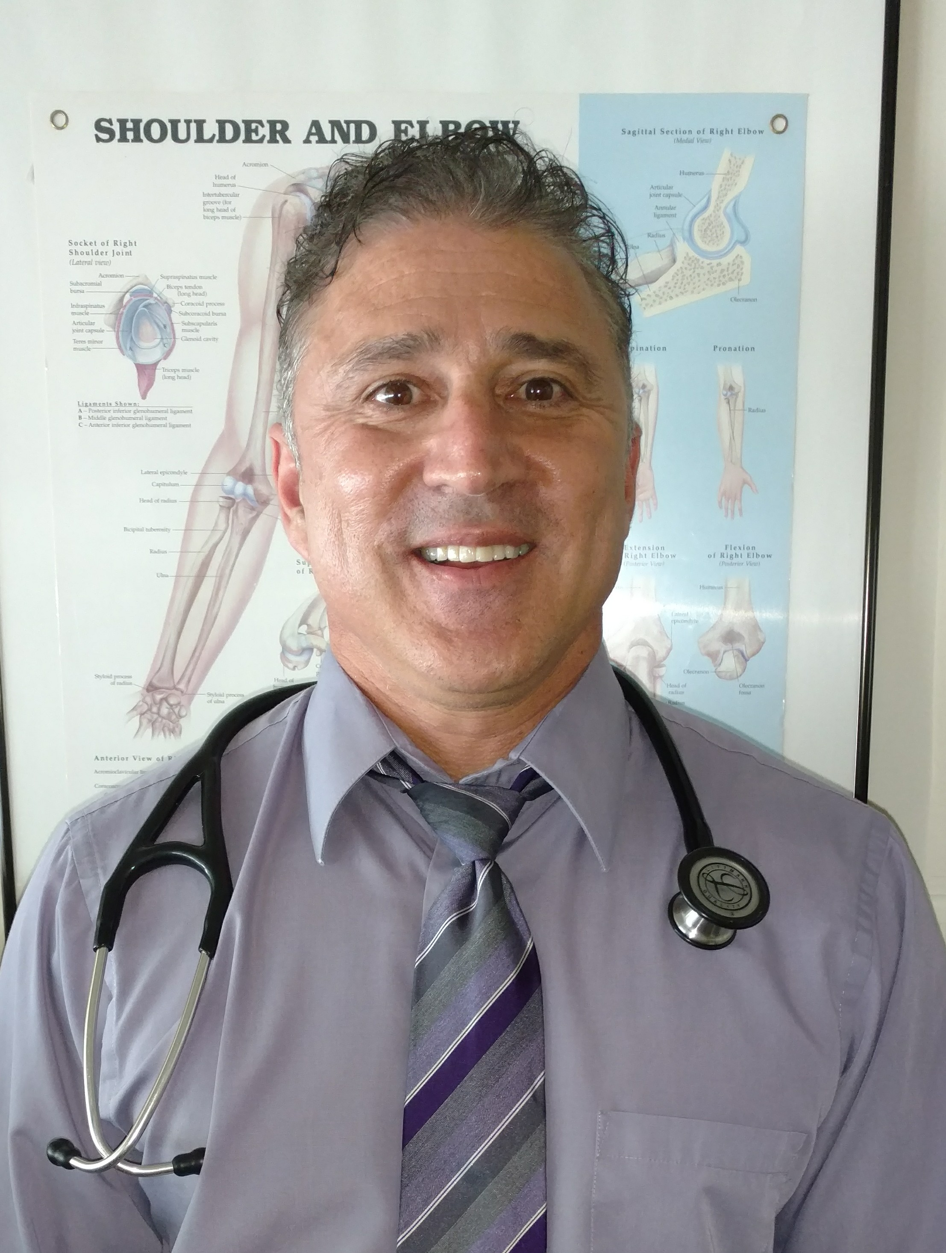  Maqsud Dean, MS, PA-C  Physician Assistant  1429 Colusa Hwy # B, Yuba City, CA 95993  (530) 755-3218

