WELCOME TO OUR PRACTICE!

We are pleased that you have chosen Centennial Eye and Cosmetic Associates for your eye care. Please take a moment to complete the enclosed Medical History form and Patient Information Paperwork. We will need these for your upcoming appointment. Many insurance companies require a co-pay and or a referral. If we are unable to bill your insurance company because of incomplete information or if a referral has not been obtained, you may be required to pay at the time of service or reschedule your appointment. We accept cash, care credit, personal checks and credit cards. Please arrive 10-15 minutes before your scheduled appointment time to give us extra time to prepare your chart. We strive to establish an appointment time that will reduce unnecessary waiting time. If you’re unable to keep this appointment we would appreciate a call -- as soon as possible -- so that the time may be rescheduled. Please do not hesitate to call our office with any questions or concerns. We look forward to seeing you soon!

Appointment Checklist:

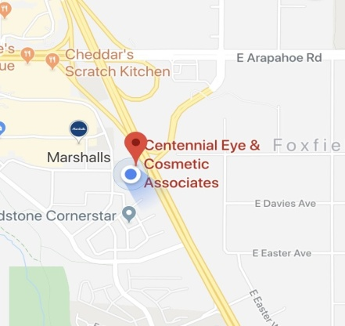
- ID & Insurance Card
- Physician Referral (If needed)
- Updated Prescription Medication List
- Completed New Patient Paperwork

