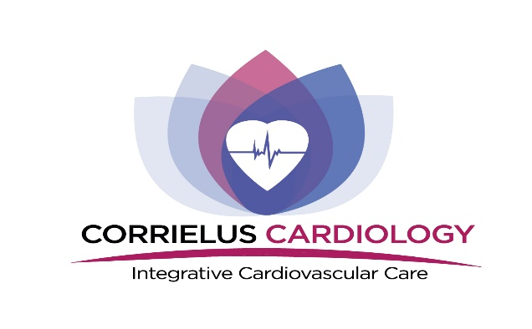
P:215-383-5900
F: 855-777-8654
Authorization to Release Medical Records
Patient Name:_____________________________ Date of Birth:_________________________
Address:______________________________________________________________________
City:___________________________________________ Zip Code:______________________
In order to provide the best care, please fill in the following information:
Records From:_________________________________________________________________
Address:______________________________________________________________________
For the purpose of:_____________________________________________________________
I, _________________________________ authorize the release of my medical records to Corrielus Cardiology.
I understand that this consent is effective for one year to date but I may revoke my consent at any time by providing written notice to the above-named party. If deemed necessary, I authorize the requested information to be sent via fax transmission.
I understand that I am herby authorizing to release medical information that may concern minors or be related to HIV (Human immunodeficiency virus), AIDS (Acquired immunodeficiency syndrome), STD’s (Sexually Transmitted Diseases), mental health or substance abuse screening and counseling.
Patient Signature:_____________________________________ Date:___________________________
Print Name:__________________________________________
Witness/Guardian:____________________________________ Relationship:______________________

