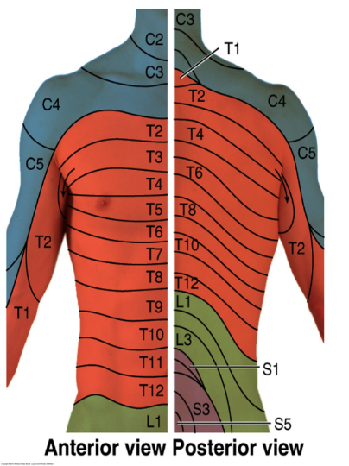
THORACIC EPIDURAL STEROID INJECTION FOR UPPER AND MID BACK PAIN
WHAT IS THE EPIDURAL SPACE?
The dura is a protective covering of the spinal cord and its nerves. The area surrounding the dura is the epidural space.
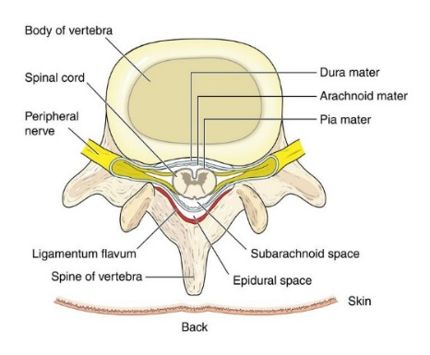
WHAT CAUSES PAIN IN THE EPIDURAL SPACE?
The thoracic area of the spine has twelve bones, called vertebrae. Soft discs found between them cushion them, hold them together and control motion. If a disc tears, chemical inside may leak out. This can inflame the dura or nerve roots, and cause pain. Bone spurs, called osteophytes, can also press against nerve roots and cause pain.
HOW DO I KNOW IF I HAVE DISC AND /OR NERVE ROOT PAIN?
Your doctor can determine the cause of your pain. If you have pain in your upper back when you move, you may have disc or dural inflammation. If pain travels to the front of your chest when you move your upper back, you may have nerve root inflammation. Tests such as MRIs can show disc bulges and nerve root compression but may not always show a torn and leaking disc. A thoracic epidural injection can help find out if a disc, dural, or nerve root inflammation is causing your pain.
WHAT IS THE PROCEDURE FOR A THORACIC EPIDURAL INJECTION?
The area to be injected will be prepped with an antiseptic solution. Using sterile technique a local anesthetic may be used to numb your skin. Fluoroscopy, a type of x-ray, is used to ensure correct needle placement and safety. A thin needle will be placed directly into the epidural space. A dye will be injected to make sure the needle is in the correct spot. The injection may be placed in the interlaminar space (behind), transforaminal (side) or if placed next to an individual nerve root, it is called a selective nerve root block. The medicine injected is an anesthetic (numbing medicine) and a corticosteroid (anti-inflammatory).

WHAT HAPPENS AFTER AN INJECTION?
You may be monitored for up to 30 minutes after the injection. Ice will be applied to the injection site. Before you leave, the clinic will give you discharge instructions as well as a pain log. Keeping track of your pain helps the doctor know what the next steps will be.
You may want to check for pain by moving your back in ways that hurt before the injection, but do not overdo it. You may feel immediate pain relief and numbness in your back and chest for up to six hours after the injection. This means the medication has reached the right spot. Your pain may return after this short pain free period, or may be a little worse for a day or two. This is normal. It may be caused by needle irritation or by the steroid itself. Steroids usually take two or three days to start working, but can take up to fourteen days.
You may be able to return to work the day after the injection, but always check with your doctor.
HOW LONG CAN I EXPECT PAIN RELIEF?
Depending on the amount of inflammation, an injection could offer several months of pain relief before further treatment is needed. For some, a single injection could result in long term relief. If your pain is caused by injury to more than one area, only some of your symptoms will be helped by a single injection.

