LUMBAR RADIOFREQUENCY ABLATION (RFA) FOR CHRONIC LOWER BACK PAIN
WHAT IS THE NEXT STEP IN ADDRESSING MY LOW BACK PAIN?
By this point you will have completed two medial branch block injections, receiving at least 80% pain relief for even a short period of time. Blocking these nerves tell the brain when a facet joint has been injured. The best way to diagnose facet pain is to block the pain signal in a medial branch nerve.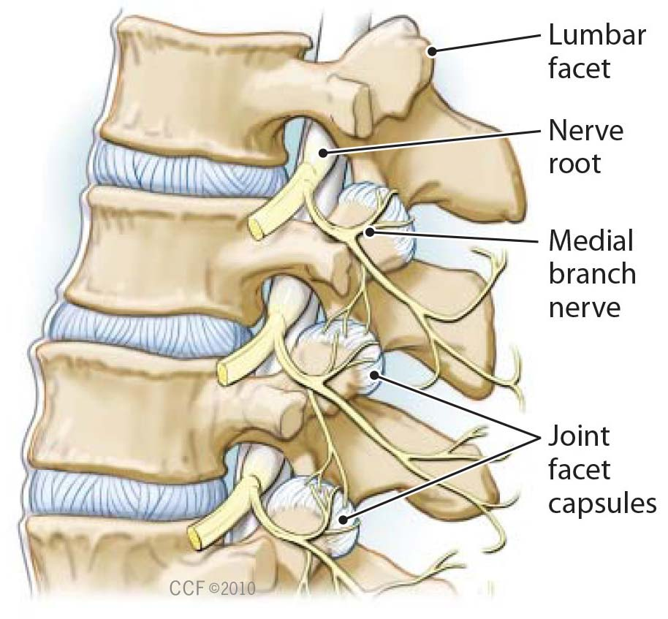

WHAT IS A LUMBAR RADIOFREQUENCY ABLATION (RFA)?
During the procedure, radiofrequency energy is used to disrupt function of a lumbar medial branch nerve, so that it can no longer transmit pain signals from an injured facet joint.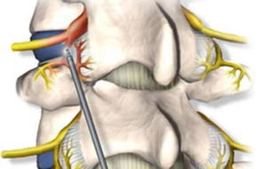
WHAT HAPPENS DURING A LUMBAR RADIOFREQUENCY ABLATION (RFA)?
An RFA may start with an IV (medicine given intravenously) to help you relax. The procedure site is prepped with an antiseptic. Using sterile technique a local anesthetic may be used to numb your skin.
Fluoroscopy, a type of x-ray, will be used to position a thin needle near the facet joint. The doctor will then check that the needle is in the proper position by stimulating the nerve. This may cause muscle twitching and provoke some of your pain.
With the needle in the correct position, the area will be numbed. Your doctor will then use radiofrequency energy to disrupt the medial branch nerve. This will be repeated at each level that has been identified by the previous medial branch block injections.
WHAT HAPPENS AFTER THE PROCEDURE?
Ice will be applied to the area, you may also eat or drink something. You may be monitored for up to 30 minutes after the procedure. Before you leave, the clinic will give you discharge instructions. You will not have to keep a formal pain log, however, over the next several days to weeks, pay attention to how your pain after the procedure compares to how you felt prior to the RFA.
You may feel sore for one to four days. This is normal and may be caused by muscle and nerve irritation. Your lower back may feel numb, weak, itch or sensitive, such as a mild sunburn might feel, for a couple of days to weeks. Be patient, as full pain relief normally takes two to three weeks and may take as long as up to six weeks.
You should be able to return to work the day after the procedure, but always check with your doctor. You will return to our clinic for follow up appointments three and six weeks after the procedure.
HOW LONG CAN I EXPECT PAIN RELIEF?
Nerves regenerate after an RFA, but how long this takes varies. Your pain may or may not return when the nerves regenerate. You have to have at least 50% pain relief for six months in order to repeat a RFA.

