LUMBAR MEDIAL BRANCH BLOCK FOR CHRONIC LOWER BACK PAIN
WHAT AND WHERE ARE FACET JOINTS AND MEDIAL BRANCH NERVES?
Facet joints are found on either side of your spine. They connect the vertebrae and help guide the spine during movement. Medial branch nerves, located near facet joints, transmit pain signals from the facet joints to your brain. They are sensory nerves.
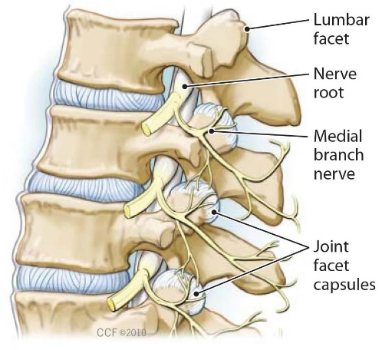
WHY WOULD I GET LUMBAR MEDIAL BRANCH BLOCK(S)?
If you had significant pain relief, even for several hours after you had lumbar facet joint injections, but not long lasting pain relief, then you may be a candidate for medial branch blocks.
WHAT IS THE INJECTION PROCEDURE FOR MEDIAL BRANCH BLOCKS?
The injection may start with an IV being placed. During this procedure a local anesthetic may be used to numb your skin. Fluoroscopy, a type of x-ray, will be used to ensure the safe and proper position of the needle. A dye will also be injected to make sure the needle is in the correct spot. Once the physician is sure the needle is correctly placed, the medicine will be injected. The doctor will then insert a thin needle near the medial branch nerve. A local anesthetic (numbing medicine) is injected near the nerve. This stops the transmission of pain signals from the facet joint. If your pain is reduced and you are able to move your back normally, then the doctor will know which facet joint has been causing your pain.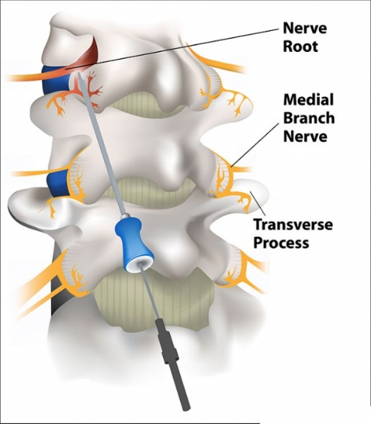
WHAT HAPPENS AFTER THE INJECTION?
Ice will be offered to apply over the injection site. You may be monitored for up to 30 minutes depending on how you are feeling. Before you leave, the nurse will give you discharge instructions as well as a pain log to complete for the next six hours. Please remember to compare how your low back pain was before your injection and how it feels after the injection. You may want to check for pain by moving your low back in ways that hurt before the injection, but don’t overdo.
HOW LONG WILL I HAVE PAIN RELIEF?
You may feel immediate pain relief as well as numbness in your low back for up to six hours after the injection. This means the medicine reached the right spot. Your pain will likely return as the numbing medicine wears off. Complete your pain log and call in the numbers to our office the next day. Your doctor will review the information and our office will contact you regarding the next step.
If you received greater than 80% pain relief, a second medial branch block will be performed. If you get similar results with the second block, then you will proceed on to a lumbar radiofrequency ablation. This procedure provides a more permanent disruption of pain signals, possibly up to 16 months.
If you did not meet the criteria for a second medial branch block procedure we will schedule you for a follow up appointment to reassess.
You should be able to return to work the day after the injection, but always check with your doctor.

