LUMBAR FACET INJECTION FOR CHRONIC LOW BACK PAIN
WHAT ARE LUMBAR FACET JOINTS?
Facet joints connect the vertebrae (the bones of the spine) and help guide the spine during movement. The lumbar region of the spine contains five vertebrae and is located in the lower back. Facet joints are found on both sides of the spine.
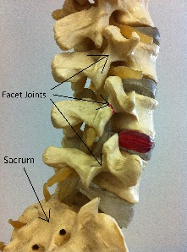
WHAT IS LUMBAR FACET JOINT PAIN LIKE?
If you have pain in one or more of these areas when you bend your back and it has lasted longer than two months, then you may have facet pain. Lumbar facet joint pain is a result of injury, either to the cartilage inside the joint or the connecting ligaments surrounding the joint. Pain from an injured joint may range from muscle tension to more severe pain. Depending on which joint is affected, the pain may occur in an area from your low back down to your buttocks.
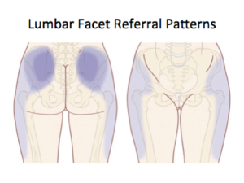
WHAT IS A LUMBAR FACET INJECTION?
During this procedure, a local anesthetic (numbing medicine) and a corticosteroid (anti-inflammatory medicine) are injected into one or more lumbar facet joints.
The injection can be used to diagnose or treat. If the injection temporarily lessens your pain and helps you move better, your doctor will know which facet joint is causing the pain. The corticosteroid is used to treat inflammation of the facet joint.
WHAT HAPPENS DURING AN INJECTION?
The area to be injected will be cleansed with an antiseptic. Fluoroscopy, a type of x-ray, may be used to ensure the safe and proper position of the needle. A local anesthetic may be used to numb your skin. The doctor will then insert a thin needle directly into the facet joint. A dye may also be injected to make sure the needle is in the correct spot. Once the needle is correctly place the medicine will be injected.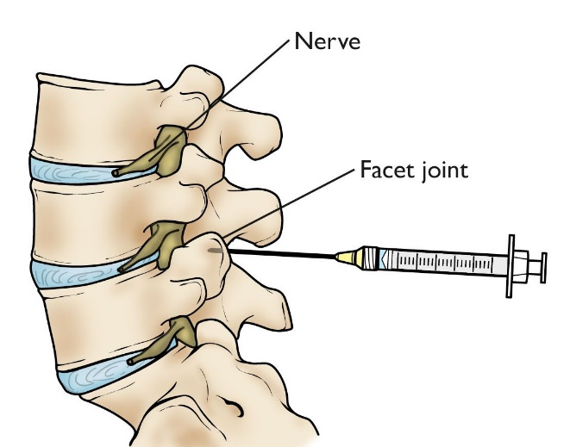

WHAT HAPPENS AFTER AN INJECTION?
You may be monitored for up to 30 minutes after the injection. Ice will be applied to the injection site. You will be offered something to eat or drink. Before you leave the clinic will give you discharge instructions and a pain log to complete. Keeping track of your pain helps the doctor know what the next step will be. You may want to check for pain by moving in ways that hurt before the injection, but do not over do. You may feel immediate pain relief and numbness in your back for up to six hours after the injection. This means the medication has reached the right spot. Your pain may return after this short pain free period, or may even be a little worse for a day or two. This is normal. It may be caused by needle irritation or by the corticosteroid itself. Corticosteroids usually take two or three days to start working, but can take as long as a week. You should be able to return to work the day after the injection, but always check with your doctor.
HOW LONG CAN I EXPECT PAIN RELIEF?
Depending on the number of injured areas and the amount of inflammation, an injection could offer several months of pain relief before further treatment is needed. If there is no underlying bone or joint problem, one injection could bring long-term pain relief. If your pain is caused by injury to more than one area, only some of your symptoms may be helped by one injection.

