LUMBAR EPIDURAL STEROID INJECTION FOR LOWER BACK AND LEG PAIN
WHAT IS THE EPIDURAL SPACE?
The dura is a protective covering of the spinal cord and its nerves. The area surrounding the dura is the epidural space. In the low back, this space is called the lumbar epidural space.
WHAT CAUSES PAIN IN THE EPIDURAL SPACE?
The lumbar area of the spine has five bones, called vertebrae. Soft discs between the vertebrae act as cushions, offering support and help to control motion. If a disc tears, chemicals inside may leak out, causing inflammation of nerve roots or the dura, and pain. A large tear may cause a disc to bulge, resulting in inflammation and pain. Bone spurs, called osteophytes, can also press against nerve roots and cause pain.
HOW DO I KNOW IF I HAVE DISC AND/OR NERVE ROOT PAIN?
Your doctor can determine the cause of your pain. If you have pain in your lower back when you move, you may have disc or dural inflammation. If pain travels to your leg when you bend your back, you may have nerve root inflammation. Common tests, such as MRIs, can show disc bulges and nerve root compression, but may not show a torn or leaking disc. A lumbar epidural injection can help determine if disc, dura or nerve root inflammation is causing your pain.
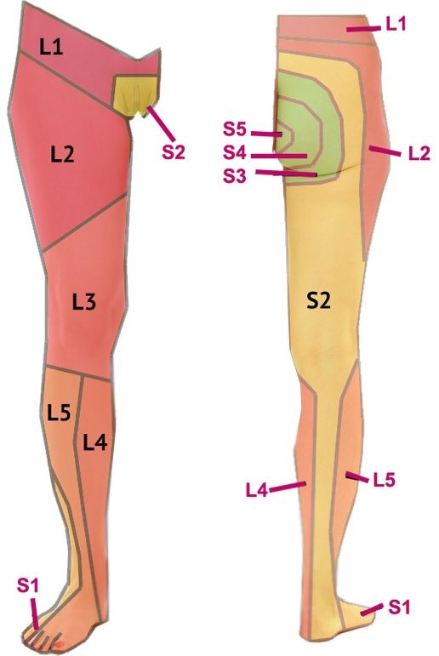

WHAT IS A LUMBAR EPIDURAL STEROID INJECTION?
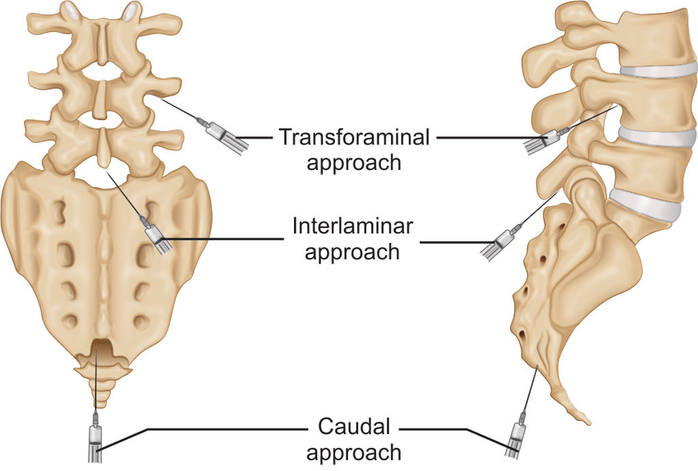
During this procedure, a local anesthetic (numbing medicine) and a corticosteroid (anti-inflammatory medicine) are injected into the epidural space to reduce inflammation. Your physician may inject into this space from behind, which is called an interlaminer injection. From the side, called a transforaminal injection or from below, called a caudal injection. If the needle is positioned next to an individual nerve root, it is called a selective nerve root block.
WHAT HAPPENS DURING AN INJECTION?
You may be given an IV, then the area will be cleansed with an antiseptic solution. Using sterile technique, a local anesthetic may be used to numb the skin. Fluoroscopy, a type of x-ray, will be used to ensure safe and proper position of the needle. The doctor will insert a thin needle into the epidural space. A dye may also be injected to make sure the needle is in the correct spot. Once the needle is correctly placed, the medicine will be injected.
WHAT HAPPENS AFTER THE INJECTION?
Ice will be applied to the injection site. You may be monitored for up to 30 minutes after the injection. Before you leave, the clinic will give you discharge instructions as well as a pain log. Keeping track of your pain helps the doctor know what the next steps will be. You may want to check for pain by moving your back in ways that hurt before the injection, but do not overdo. You may feel immediate pain relief and numbness in your back and leg for up to six hours after the injection. This means the medication has reached the right spot. Your pain may return after this short pain free period, or may be a bit worse for a day or two. This is normal. It may be caused by needle irritation or by the steroid itself. Steroids usually take two or three days to start working, but can take as long as fourteen days. You should be able to return to work the day after the injection, but always check with your doctor.
HOW LONG CAN I EXPECT PAIN RELIEF?
Depending on the amount of inflammation, an injection could offer several months of pain relief. If pain is caused by injury to more than one area, only some of your symptoms will be helped by a single injection.

