CERVICAL (NECK) FACET INJECTION FOR CHRONIC NECK PAIN AND HEADACHE
WHERE AND WHAT ARE FACET JOINTS?
Facet joints are found on either side of your spine (neck). They are small joints that connect to the vertebrae and guide the movements of your spine.
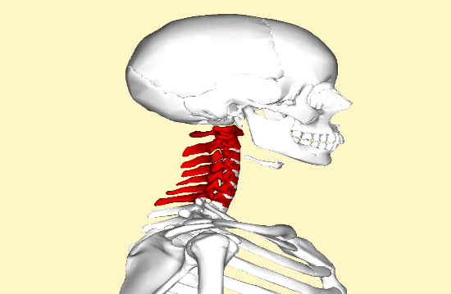
WHY WOULD I HAVE FACET JOINT PAIN?
Facet joint pain can be from an injury to the cartilage inside the joint, i.e. arthritis or injury to the connecting ligaments of the joint. Pain can range from mild muscle tension, decreased movement, stiffness, and/or headache to severe pain. Each facet joint has a referral pain pattern.
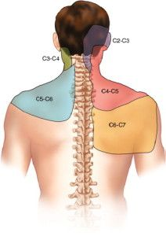
WHAT ARE THE SIGNS AND SYMPTOMS OF FACET JOINT PAIN
Pain and possibly stiffness in the morning or with inactivity, pain with turning your head to the side or looking up. X-rays and MRIs may not always show if a facet joint is the source of your pain.
WHY WOULD I GET A CERVICAL FACET JOINT INJECTION?
If you are having pain a cervical facet joint injection can be used to diagnose and treat your pain. If the injection temporarily lessens your pain and helps you move better, your doctor will know which facet joint is causing the pain. The corticosteroid is used to treat inflammation of the facet joint.
WHAT IS THE INJECTION PROCEDURE?
For certain injection procedures an IV may be required. You will be taken to the treatment room and be placed in the appropriate position for your injection. A local anesthetic may be used to numb the skin. Fluoroscopy, a type of x-ray, may be used to ensure the safe and proper position of the needle. A dye may also be injected to make sure the needle is in the correct spot.
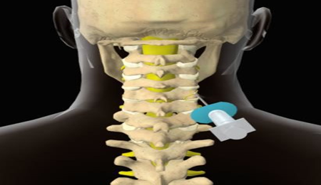
WHAT HAPPENS AFTER AN INJECTION?
Ice will be offered to apply over the injection site. You may be monitored for up to 30 minutes depending on how you are feeling. Before you leave, the nurse will give you discharge instructions as well as a pain log. Please remember to compare how your neck/headache pain was before your injection to how it feels after the injection.
You may want to check for pain by moving your neck in ways that hurt before the injection, but don’t overdue. You may feel immediate pain relief as well as numbness in your neck, head or arm for up to six hours after the injection. This means the medication reached the right spot. Keep icing the area as you were directed on your discharge papers. Your pain may return after this short pain free period, or may even worsen for a day or two. This is normal. It may be caused by needle irritation or by the steroid itself. Steroids can take two the three days to start working, but may take up to 14 days. You should be able to return to work the day after your injection, but check with your doctor.
How long will I have pain relief?
Depending on the number of injured areas and the amount of inflammation, an injection could offer several months of pain relief. If there is no underlying bone or joint problem, one injection could bring long term relief. If your pain is caused by injury to more than one area, only some of your symptoms may be helped by one injection. If that is the case, you will be reevaluated for additional treatment options.

