CERVICAL EPIDURAL STEROID INJECTION FOR NECK AND ARM PAIN
WHAT IS THE EPIDURAL SPACE?
The dura is a protective covering of the spinal cord and its nerves. The area surrounding the dura is the epidural space. In the neck, this space is called the cervical epidural space.
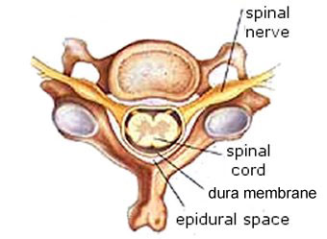
WHAT CAUSES PAIN IN THE EPIDURAL SPACE?
The cervical area of the spine has seven bones, called vertebrae. Soft discs between the vertebrae act as cushions, offering support and helping to control motion. If a disc tears, chemicals inside may leak out, causing inflammation of nerve roots or the dura, and pain. A large tear may cause a disc to bulge, resulting in inflammation and pain. Bone spurs, called osteophytes, can also press against nerve roots and cause pain.
HOW DO I KNOW IF I HAVE DISC AND NERVE ROOT PAIN?
Your doctor can determine the cause of your pain. If you have pain in your neck or upper back when moving your head, it may be caused by disc or dural inflammation. Often, pain that travels to your arm when you move your head is caused by nerve root inflammation. 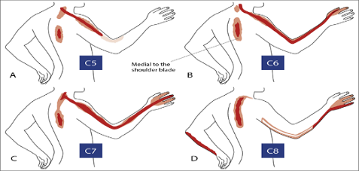
Common tests, such as MRIs, can show disc bulges and nerve root compression, but may not always show a torn and leaking disc. A cervical epidural injection can help to determine if disc problems, or dural or nerve root inflammation are causing your pain.
WHAT IS A CERVICAL EPIDURAL STEROID INJECTION?
During this procedure, a local anesthetic (numbing medicine) and a corticosteroid (anti-inflammatory medicine) are injected into the epidural space to reduce inflammation. Your physician may inject into this space from behind. This is called an interlaminer injection. When your physician goes in from the side, it is called a transforaminal injection. If the needle is positioned next to an individual nerve root, it is called a selective nerve root block.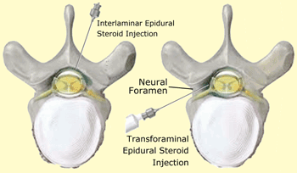
During this procedure you may be given an IV. The area will be prepped using an antiseptic solution. Using sterile technique, a local anesthetic may be used to numb the skin. Fluoroscopy, a type of x-ray, will be used to ensure the safe and proper position of the needle. The doctor will then insert a thin needle directly into the epidural space. A dye may also be injected to make sure the needle is in the correct spot. Once your physician is sure the needle is correctly place, the medicine will be injected. Liquid bandage will be applied to the injection site. You may be monitored for up to 30 minutes after the injection. Ice will be applied to the injection site and you can eat or drink if you wish. Before you leave, the clinic will give you discharge instructions as well as a pain log. Keeping track of your pain helps the doctor know what the next step will be. You may want to check for pain by moving your neck in ways that hurt before the injection, but do not overdo. You may feel immediate pain relief and numbness in your neck and arm for up to six hours after the injection. This means the medication has reached the right spot. Your pain may return after this short pain free period, or may even worsen for a day or two. This is normal. I may be caused by needle irritation or by the steroid itself. It may take two to three days to start working but may take up to fourteen days. You should be able to return to work the day after the injection, but always check with your doctor.
HOW LONG CAN I EXPECT PAIN RELIEF?
Depending on the amount of inflammation, an injection could offer several months of relief. For some, a single injection could result in long term relief. If your pain is caused by injury to more than one area, only some of your symptoms will be helped by a single injection.

