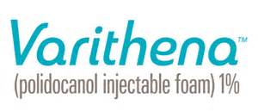
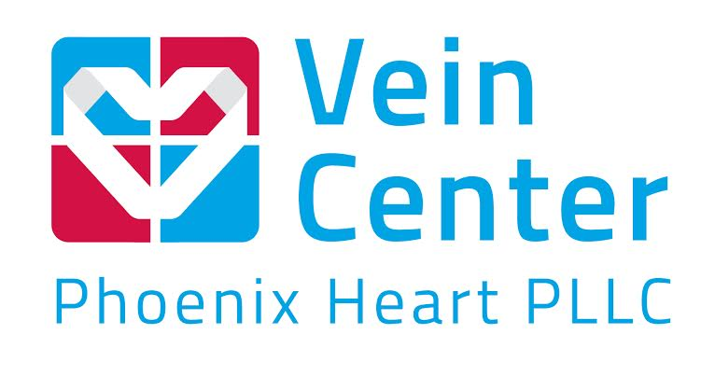
5859 W Talavi Blvd Suite 150, Glendale, AZ 85306
Phone: 602-298-7777 Fax: 623-930-6060
www.phoenixheart.com ICAEL, ICANL, and ACR accredited Facility

PATIENT COPY
Post-Operative instructions for Varithena ®
DAY 1:
Leave your compression stockings or wrapping on for 48 hours following your treatment.
YOU MAY RETURN TO NORMAL DAILY ACTIVITY ON THE DAY OF YOUR TREATMENT – WALKING IS ENCOURAGED.
Day 2: After 24 hours after treatment: Keep leg wrapped.
Day 3: After 48 hours after treatment:
- You may remove your compression stockings or bandages and cotton.
- Take a shower- Lukewarm water
- The injection sites may be washed with a mild soap and tepid water.
- Walking is encouraged.
NEXT 1-2 Weeks:
For the next 1-2 weeks following your treatment wear your compression stockings ONLY during the DAY. Remove them at night. You do not need to sleep in them.
SIDE EFFECTS: Should any of the following occur, contact your physician IMMEDIATELY
- A sudden onset of a swollen leg
- Formation of small ulcers or blisters (fluid filled sacs) at the injection site
- Increased redness or streaking, leg(s) swollen or warm to touch
- Increased pain, drainage of any kind or any sign or symptoms of infection
Medication to AVOID 48 hours after treatment:
- Aspirin (unless taking a daily 81mg Aspirin - DO NOT STOP taking that medication.)
- Ibuprofen or other anti-inflammatory medications. (Tylenol may be used if needed)
- Iron Supplements
Activity to AVOID 72 hours after treatment:
- Hot baths, Whirlpools, saunas or hot compresses
- No oils, lotions, creams or powders to legs
- No swimming
Activity to AVOID 1 week after treatment:
- No tanning beds or outside tanning/ avoid prolonged sun exposure
- Running, High-impact exercise and high-impact aerobics/sports
- Weight lifting/ Leg press.

CONTACT INFO:
If you have any concerns, call (602) 298-7777 You may Call this same number after hours or on weekends and our answering service will take your message and page the On-Call physician. If you are experiencing a true vascular emergency, call 911 or go immediately to the nearest Emergency Room

