**Advanced Arthritis and Rheumatology Center**

**12225 South Street, Suite 105, Artesia, CA 90701**

BRIEF HISTORY FORM

**Please take a moment to fill out the following forms as thoroughly as possible.**

Patient Name:____________________________________ Date of Birth:___________ Age:________

Mailing Address:_______________________________________ Email: _________________________

City:____________________________State:_________________Zip:_______________

Home phone:__________________ Cell phone: __________________Work Phone_________________

Sex:_______ Marital Status: ______________________ Social Security Number: ___________________

Primary Care Physician:___________________________ Phone number:_________________________

Referring Physician: _______________________________Phone number: ________________________

Pharmacy Name: _________________________________Phone number:_________________________

Notify in case of emergency:________________________Phone: ________________Relation: ________

Primary insurance:________________________ Insured’s Name and DOB:_______________________

Secondary insurance:______________________ Insured’s Name and DOB:________________________

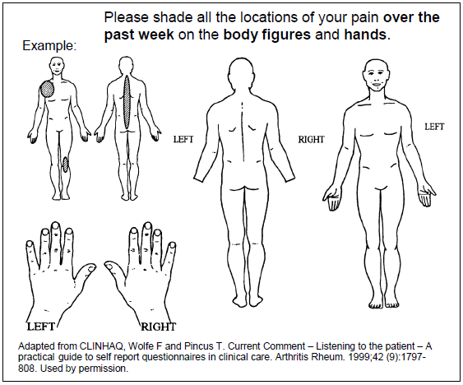

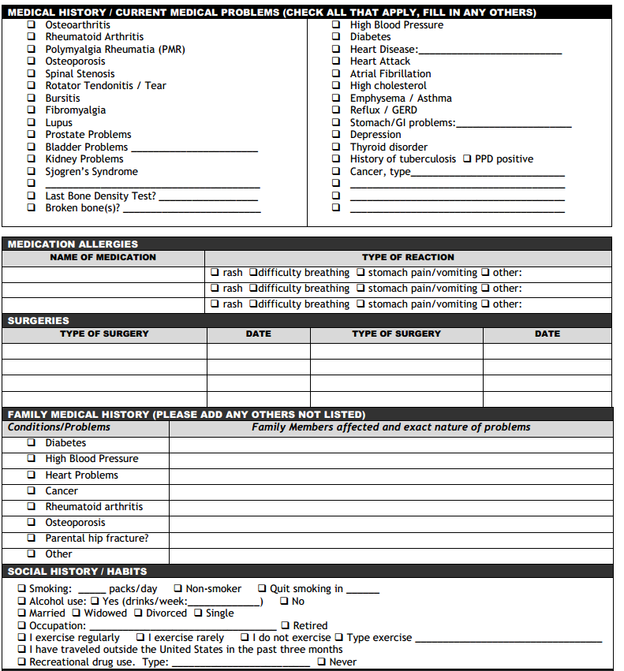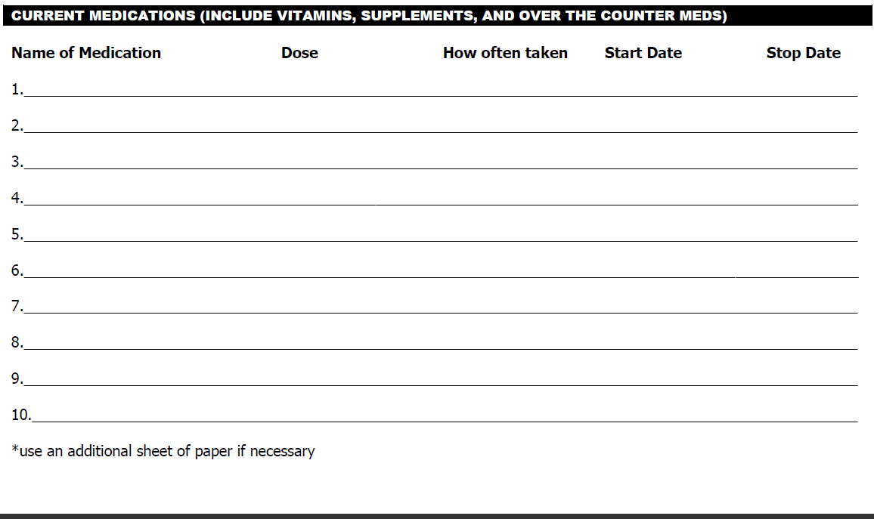

**Please fill out following if applicable**

|  |
| --- |
| **Date of last procedure Place where done Date when done** |
| **Eye exam for Plaquanil** |
| **Chest X-ray** |
| **MRI/CT scan (Rheum. Related)** |
| **Bone Density** |
| **TB/PPD skin test** |
| **Colonoscopy/Guiac stool exam** |
| **Mammogram** |

**Patient Signature: ___________________________________ Date: ___________________**

**Dr. Dipti Doshi M.D.: _________________________________ Date: ___________________**