Informed Consent for Care 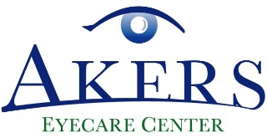
Akers Eyecare Center (AEC) is taking all reasonable precautions recommended for optometrists by the Centers for Disease Control and Prevention who are providing eye care and related services to patients during the COVID-19 crisis, and is following the recommendations of the American Optometric Association and our local state regulatory authorities. Additionally, AEC is screening its employees and patients to ensure that no employee or patient is currently suffering any of the known symptoms of COVID-19, including running a fever, having a dry cough, or experiencing shortness of breath.
However, it is also known that those without symptoms may still be capable of infecting others as an asymptomatic individual with COVID-19 and despite precautions taken the virus may still be present and capable of infecting individuals. Knowing this information, I voluntarily elect to continue with my scheduled appointment with AEC and I hereby acknowledge that I do so having first been informed and understanding that it is not possible to guarantee a virus-free or infection risk-free environment, but I am willing to assume that risk.
I affirm that I am at least 18 years of age and am freely signing this agreement or that I am signing on behalf of a minor child that I have the legal authority to sign such agreements on behalf of. I have read this form and fully understand that by signing this form I am accepting the known risk of becoming infected with the COVID-19 virus.
Dated: ____________________
Patient: ___________________________________
Print Name: ___________________________________
Relationship: ___________________________________

Signature: ___________________________________

Temperature: ___________________________________

