Patient Registration Form Date of Appointment: _
Patient's Address
City
State
Zip
Pharmacy Phone
Pharmacy Address
Occupation
Employer/School Phone
Employer/School Address
City
State
Zip
Emergency Contact Information
Emergency Contact Name
Emergency Contact Phone
Relation to Patient
Patient Information
Patient's First Name | Middle Name | Last Name (as it appoor.; on insurance card or ID)
Sex Marital Status | Date of Birth (Age) | Social Security Number

Home Phone |  | Mobile Phone | Email Address
Referred by |  | Primary Ca.re Physician | Primary Care Physician Phone

Billing and Insurance
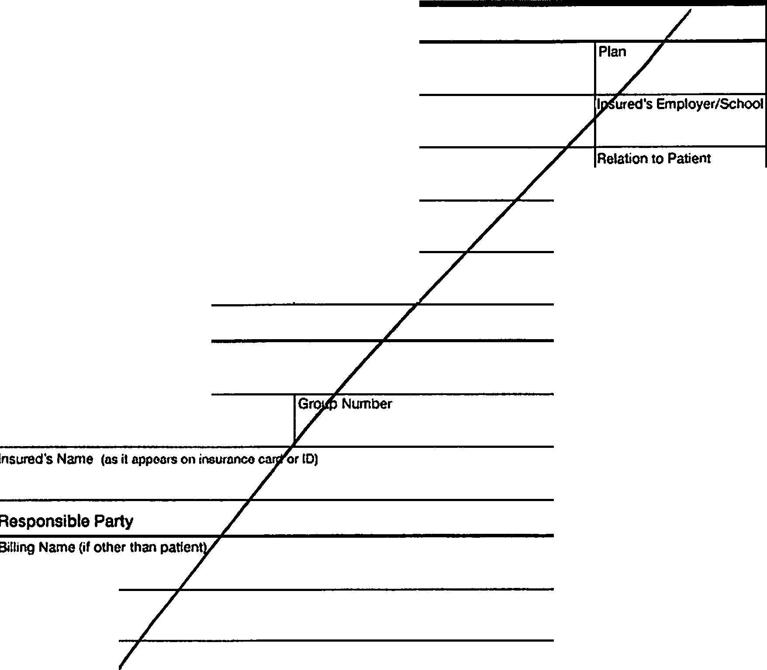
Primary Health Insurance
Insurance Company
Plan Number
Group Number
lnsured's Name (as it flf)pears on 111suraoce card or ID)
lnsured's Address
City
State
lnsureo's Social Security Number
lnsured's Birthdate
Secondary Health Insurance
Insurance Company
Plan
Plan Number
lnsured's Employer/School
lnsured's Social Security Number
Relation to Patient
lnsured's Phone Number
Responsible Party
Phone
Address
City
State
Zip
TREATMENT CONSENT
1 hereby consent and given my permission to the doctor (and the doctors assistants or designated replacement) to adminster and perform such procedures upon me as the doctor deems necessary.

Signature of Patient or Authorized Guardian Date

Date of Appointment: _

Name Gender Age
Reason for Visit Lifestyle Factors

What brings you to the office today?

Have you ever smoked?
CJ Yes [] No # of years #packs/day _ Do you smoke now?

Cl Yes O No # packs/day _

Please describe any previous treatment and care you have received for this problem.

Pain Assessment
Indicate your level of pain on a scale of 1 - 1O. ( 10 = worst pain imaginable )
□ □
1 2 D 3 [] 4 CJ s [J e [J 1 [J a [] 9 Cl 10
Check the symptoms that best describe your problem.
[] Stiffness [] Pain [] Instability [1 Swelling
Do you use recreational drugs?
U Yes O No types? #times/week _ How much alcohol do you drink per week?
# drinks/week-----------
How much caffeine do you drink per day?
# drinks/day _

Athletic Activities/How often do you exercise? #times/week _
Your Occupation/How many hours a day do you stand?
# of hours _

What type of shoes do you wear?
[] Flat D Heels [] Boots [] Loafers [] Oxfords

[] Numbness [1 Other:
Are your symptoms getting...
D Better Gradually [] Better Rapidly
[} Worse Gradually [] Worse Rapidly
What improves your symptoms?
[] Sandals D Sneakers Other: _

Hospitalizations & Surgeries

!J Rest [.l Ice [] Heat [] Other:
What makes your symptoms wm:ae?
[] Activity [] Cold
[] Motrin/ Aleve
Date

Reason Date

D Other:
Podiatry
Do you have any of the following?

Current Medications
Are you currently taking any blood thinners?

r···j Ankle Sprain
OArchPain
O Athlete's Foot [) Broken Ankle
0 Broken Foot Bones
[J Bunions
LJ Burning in Feet
0 Corns I Calluses [J Cramps in Feet 0 Cramps in Legs
[] Enlarged Veins
FlatFeet
□
C:IFoot Numbness
0 Foot Ulcers [] Fungal Nails
[] High Arch Feet [] Heel Pain
0 Hammer Toes
D Ingrown Nails
ClIn-toeing
[]Knee Pain [] Leg Ulcers
[) Loss of Sensation in
[) Lower Back Pain
D Rash on Feet
D Swelling in Ankles
D Swelling in Feet Swell []inLegs
D Plantar wart
[] Yes []No

eet What medications are you currently taking?

Name Dosage Frequency

Name Dosage Frequency

Do you currently or have you ever worn orthotics?
LJYes ONo
Does your foot pain limit your desired activity? [] Yes !!No
Are your first steps out of bed in the morning painful?
Oves LJNo

Are you allergic to any of the following?
0 Adhesive Tape [_J Penicillin

ULatex

D Barbiturates _{(Sleeping} Pills) i ! Aspirin
LJlodine

Have you ever had any other foot problems?
Oves ONo
[] Codeine LJ Sulfa Do you have any other allergies?
LJ Local Anesthetics

If so, please describe:
Name Reaction

Name Reaction

Name Gender Age
Date of Appointment: _

Past Medical History
Have you ever had any of the following?
LJAlcoholism D Back Problems 0 Ear Problems
□Allergies 0 Bleeding Disorder 0 Ealing Disorder
□Anemia 0 Blood Disease [] Epilepsy
0 Anxiety Disorder D Blood Transfusion OGlaucoma
□Arthritis □c ancer OGout
OAsthma 0 Diabetes 0 Heart Disease
□AIDS / HIV D Depression 0 Heart Problems

0 Hepatitis - A. B. or C OMeasles 0 Skin Disorder [] High Blood Pressure OMigraines 0 Stomach Ulcer
D High Cholesterol D Osteoporosis 0 Substance Abuse D Joint Disorder 0 Pneumonia 0 Thyroid Disorder D Kidney Disorder OPolio D Tuberculosis
0 Liver Disorder 0 Rheumat,c Fever 0 Venereal Disease
D Lung Disease Ostroke

Family History
Has anyone in your family ever had any of the following conditions?
i i Alcoholism D Cancer OJoint Disorder n Allergies O Depression O Kidney Disease n Alzheimer's O Diabetes O Liver Disorder
Women Only
Are you pregnant?

_ Oves ONo

Are you breastfeeding?
Oves nNo

i lAnemia
! l Anxiety LJArthritis UAsthma

LJAIDS/HIV
L Bleeding Disorder
!i Blood Disorder

Details:
D Epilepsy
0 Genetic Disorder
□Glaucoma
D Heart Disease
□Hepatitis
0 High Cholesterol
0 High Blood Pressure
D Lung Disease
D Migraines
D Psychiatric Disorders
D Osteoporosis
D Stroke
D Substance Abuse
D Thyroid Disorder

Other Notes:

ALBERT SAMANDAROV, DPM

MATVEY YAGUDAYEV, DPM
ASTORIA
31-16 30TH AVENUE
Surrt: 203
AsroRIA, NY 11102

INSURANCE ASSIGNMENT AND RELEASE
I certify that I have insurance coverage with
and assign directly to Dr. all insurance benefits, if any, otherwise payable to me for servicesrendered. I understand that I am financ ia lly responsiblefor all charges whether or not paid by insurance. I hereby authorize the release of any informatio n necessa ry to secure payment of benefits. I authorize the use of my sig nature on all insurance submiss io ns.
The above-named doctor may use my health care information and may disclose such information to the above-named Insurance Company(ies) and their agents for the purpose of obtaining payment of services and determining ins urance benefits or the benefits payable for related services.
Signature Date _

PRIVACY PRACTICES

I have receiveda copy of this office' s Notice of Privacy Practices and I have been provided an opportunity to review it.
@ s ignature _ _ _ _ _ _ _ _ _ _ _ _ _ _ _ _ Date_ _ _ _ _ _ _ _ _ _

E-PRESCRIBING CONSENT/ACKNOWLEDGMENT

I hereby author ize my physician to prescribe and refill med ications through a computerized e-prescribing system. I under stand that my physician may be sending my prescriptions electronically, and I have been informed on the E-pr escrib ing process.
I a lso give permission for Ideal Foot Care, PC to obtain my medication history from my pharmacy, my hea lth plans and my other healthca re providers.
Signature Date._ _ _ _ _ _ _ _ _ _

CANCELLATION POLICY

I, _ _ _ _ _ _ _ _ _ _ _ _ _ _ , agree to a penalty fee of$50.00 to be paid if! miss or cancel my office appointment less than 24 hours prio r to the date, regard less if it is re-scheduled or not.
The fee will be waived in cases of inclement weathe r, for illness, or emergency. The fee is to cover loss of business and administrat ive cost incurred by office.
Signature_ _ _ _ _ _ _ _ _ _ _ _ _ _ _ _ Date_ _ _ _ _ _ _ _ _ _

31-16 30th avenue, suite 203, Astoria NY 11102 • Astoriapodiatrist.com

Phone: 718.626.3338 ■ Fax: 718.626.3034

