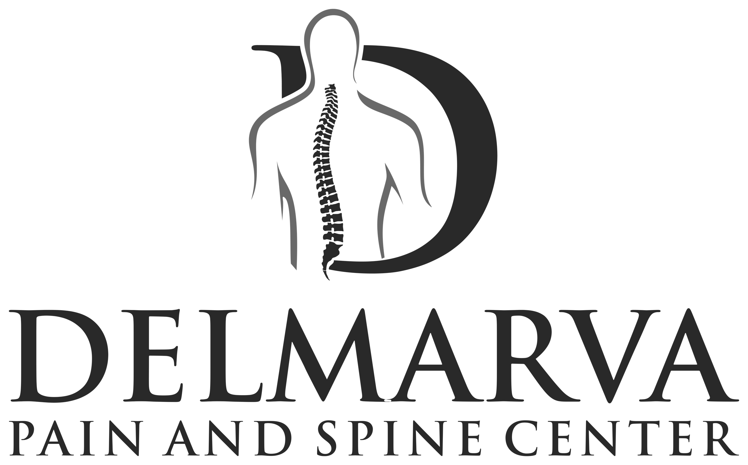 | MOTOR VEHICLE ACCIDENT INTAKE FORM | Phone (302) 355-0900  Fax (302) 355-0901  Web delmarvapain.com

AUTO ACCIDENT INFORMATION

Patient’s Name: | Date of Birth:
PLEASE PROVIDE THE FOLLOWING INFORMATION:
Auto Insurance Company:
Address:
Claim #: | Adjustor Name:
Date and State of Accident: | Adjustor Phone #:
Briefly describe the accident and injuries:
If you have an attorney representing you on this case, please provide the following:

Attorney’s Name:
Attorney’s Phone Number:
In the event my claims are denied from the above listed insurance carrier, I understand my personal health insurance will be billed. Therefore, for my protection, I will obtain the necessary referrals if applicable.

I understand that I am responsible for any payment of all services rendered should my claims be denied.

Signature: X | Date:

