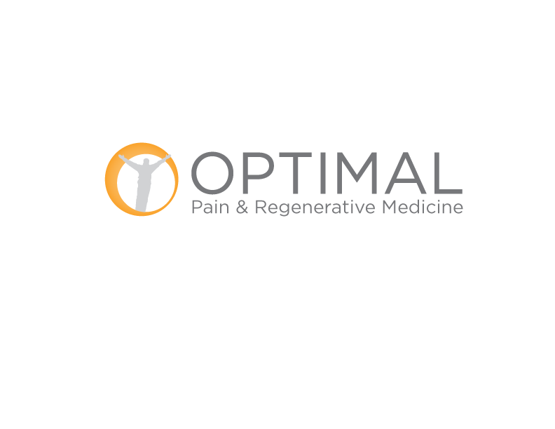
NOTICE OF PRIVACY PRACTICES
THIS NOTICE DESCRIBES HOW HEALTH INFORMATION ABOUT YOU MAY BE USED AND
DISCLOSED AND HOW YOU CAN GET ACCESS TO THIS INFORMATION
PLEASE REVIEW IT CAREFULLY
Optimal Pain & Regenerative Medicine, herein referred to as “Optimal” is issuing this Notice of Privacy Practices about your legal rights and our duties with respect to your health information.
OUR PLEDGE TO YOU
We understand that health information about you and your health care is personal. We are committed to protecting health information about you. We create a record of the care and services you receive from us. We need this record to provide you with quality care, bill for your care, and comply with legal requirements. This notice applies to all of the records of your care that we maintain, whether made by our staff and authorized trainees, or by your personal doctor. This notice tells you about the ways in which Optimal may use and disclose health information about you. We also describe your rights to the health information we keep about you, and describe our obligations regarding the use and disclosure of your health information.
HOW WE MAY USE AND DISCLOSE HEALTH INFORMATION ABOUT YOU
Optimal doctors, nurses, pharmacists, laboratory technicians, and other health care professionals may use health information about you to provide you with health care treatment or services. We may also disclose health information about you to others who are involved in taking care of you. For example, we may send health information about you to a specialist as part of a referral.
Optimal may use and disclose health information about you to obtain payment for the treatment and services you receive from us. For example, we may send billing information to your insurance company or Medicare. We may also tell your insurance company about a treatment you are going to receive to obtain prior approval or to determine whether your plan will cover the treatment. Optimal may send you a statement of your account if payment is due from you. We may send the guarantor (responsible party for payment) monthly statements for charges for all patients under that guarantor.
Optimal may use and disclose health information about you to support our health care operations. For example, we may use health information to review the treatment and services and to evaluate the performance of our staff in caring for you. We may combine health information about many patients to decide what additional services we should offer. We may remove information that identifies you from this set of health information so others may use it to study health care delivery without learning who our specific patients are.
We may disclose information to notify a family member or other person responsible for your care about your condition, status, and location.

If you are admitted and unless you tell us otherwise, we may provide your name, location in the hospital, and your general condition (good, fair, etc.) for information to be included in a patient directory and make this information available to anyone who asks for you by name.
We may use and disclose health information to contact you for an appointment reminder, to tell you about health-related services or recommend possible treatment options or alternatives that may be of interest to you, or to contact you about supporting our fundraising efforts.
Subject to certain requirements, we may use or disclose health information about you without your prior authorization for other reasons:
We may give out health information about you for public health purposes; to report abuse or neglect; for health oversight reviews; in research studies; for funeral arrangements and organ donation; in response to special law enforcement requests, valid judicial or administrative orders, or for authorized national security and intelligence activities; for workers’ compensation purposes; to avert a serious threat to your health or safety or those of the public or another person; and when required by law. If you are or were a member of the armed forces, we may release information about you as required by military command authorities or the Department of Veterans Affairs. If you are an inmate of a correctional institution or under the custody of a law enforcement official, we may release health information about you to the correctional institution or law enforcement official.
In any other situation not covered by this notice, we will ask for your written authorization before using or disclosing your health information. You may revoke this authorization for any subsequent disclosures by notifying us in writing.
YOUR RIGHTS REGARDING HEALTH INFORMATION ABOUT YOU
You have the right to request in writing that you inspect and obtain a copy of the health information that we use to make decisions about your care. We may charge a fee for the costs of copying, mailing or other supplies and services associated with your request. If we deny your request to inspect or obtain a copy in certain limited circumstances, you may request that the denial be reviewed. Another licensed health care professional chosen by Optimal will review your request and the denial and we will comply with the outcome of that review.
If you believe that health information we have about you is incorrect or incomplete, you may make a written request to ask us to amend information. The request should state the reason for the amendment and specific information to be amended. The amendment must be limited to one page. Any amendment we make to your health information will be disclosed to those with who we disclose information as previously stated.
We may deny your request for an amendment if the information to be amended was not created by us, is no longer maintained by us, is not part of the information which you would be permitted to inspect and copy; or is accurate and complete. We will notify you if we deny your request for amendment and you may appeal, in writing, our decision. Any statements of disagreement or rebuttal will be linked to your health information and made a part of any subsequent disclosure we make of such information.

You have the right to make a written request for a list of disclosures we have made of your health information, except for uses and disclosures for treatment, payment, and health care operations, as previously described, and those for which you have authorized disclosure. Your request must state a time period which may not be longer than six years and may not include dates prior to April 14, 2003. We will not charge you for the first list you request within a 12-month period, additional requests will be charged according to our cost for producing the list. We will notify you of the cost involved and you may choose to withdraw or modify your request at that time before any costs are incurred.
You have the right to request a restriction on the health information we use or disclose about you for treatment, payment, or health care operations. There may be risks associated with such restrictions and we may ask you to acknowledge these risks in writing for certain requests you may make. We are not required to agree to your request for restrictions if it is not feasible for us to ensure our compliance or believe it will negatively impact the care we may provide you. If we do agree, we will comply with your request unless the information is needed to provide you emergency treatment.
You have the right to request, in writing without requiring you to state a reason, that confidential communications with you be made in an alternative manner or location. We will accommodate all reasonable requests. Your request must specify how or where you wish to be contacted.
WRITTEN REQUESTS
If you have any questions about this notice, please contact: Optimal Pain & Regenerative Medicine, at 800 W. Arbrook Blvd., Suite 120, Arlington, Texas, 76015, or call (817) 468-4343.
COPIES OF NOTICE AND CHANGES
You have the right to obtain a paper copy of this notice at any time.
We reserve the right to change this notice, and to make the revised or changed notice effective for health information we already have about you as well as any information we receive in the future.
COMPLAINTS
If you are concerned that your privacy rights may have been violated or you disagree with a decision we make about your health information, you may contact Optimal Pain & Regenerative Medicine at 800 W. Arbrook Blvd., Suite 120, Arlington, Texas, 76015, or call (817) 468-4343. You may also send a written complaint to the U.S. Department of Health and Human Services. We can provide you with the address.
Under no circumstances will we ever ask you to waive your rights under this notice or retaliate against you in any manner for filing a complaint.
Please sign the attached acknowledgement that you have received our Notice of Privacy Practices, effective January 1, 2019.

Acknowledgement of Receipt of Notice of Privacy Practices
Optimal Pain & Regenerative Medicine
I received a copy of the Notice of Privacy Practices from the above noted entity.
Signature: Date:
Print Name:
Personal Representative:
If personal representative, please note relationship to patient:

