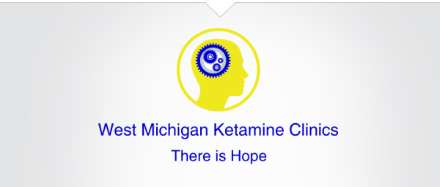

PERSONAL INFORMATION RESPONSIBLE PARTY INFORMATION

Patient Name: _____________________________ Responsible Party: ___________________________

Date of Birth: _______________ Gender: _______ Home Phone: _______________________________
Address: _________________________________
_________________________________________ Cell Phone: _________________________________

City, State: ____________________ Zip: ________ Responsible Party Relationship to Patient:
__________________________________________
Home Phone: _____________________________

Cell Phone: _______________________________ Email: _____________________________________

********Please indicate with an X which phone number we may NOT leave a message. ***********

EMERGENCY CONTACT INFORMATION

Emergency Contact Name: ________________________ Relationship to Patient: _________________

Emergency Contact Phone Number: ______________________________________________________

Source of Referral: _______________________________ Reason for Referral: ____________________

How Did you hear about West Michigan Ketamine Clinics? ____________________________________________________________________________________

FINANCIAL AGREEMENT

I understand that West Michigan Ketamine Clinics does not currently bill insurance. Upon request I will be given a receipt that I may submit to my insurance for possible reimbursement. I have been given the opportunity to ask questions regarding this statement.
________________________________ _________________________ ____________________
Signature of Patient Printed Name Date
________________________________ _________________________ _____________________
Signature of Responsible Party Printed Name Date

1

West Michigan Ketamine Clinics Practice Policies

You will be evaluated and treated by a licensed provider. We want to take this opportunity to welcome you and, also state some basic policies we believe are essential in establishing a good relationship between us. Please read through the information and please ask any questions as needed.

- Initial Consultation: Your first visit is considered and evaluation and exam. At the time of the first visit the following decisions will be made by the patient, responsible party and the provider.
- If ketamine is an appropriate treatment option
- Frequency of ketamine infusion sessions
- Goals of therapy and what the patient hopes to gain from the treatment

- Appointments: Each infusion can vary based on the patient. However, the average Ketamine infusion runs around an hour in length. You may book your next appointment at the time of each infusion you may book them out all at once.

- Cancellations: If you need to cancel an appointment please give as much notice as possible.

- Payments: Payments are to be made at the time of service or prior to. We accept VISA, MASTERCARD, Discover and American Express. We accept cash payment. WE DO NOT accept checks.

- Confidentiality: All information regarding the specific nature of your treatment is maintained at West Michigan Ketamine Clinics and is considered confidential within the office unless specified by the patient in writing to be released otherwise. Each provider reserves the right to use the specialty consultation with other medical providers within the office as deemed necessary. WMKC follows HIPAA laws.

Please initial the lines below as applicable to the statements below:
I acknowledge that I have read and understand all the foregoing statements and that my signature below indicates that I agree to abide by all the above conditions.
_______ _______
Yes No
I consent to the exchange of treatment between WMKC and my referring provider.
_______ ________
Yes No

Patient Signature: ______________________ Print Name: _________________ Date: _____________

2

HISTORY AND PHYSICAL
(to be filled out by patient)

Patient Name: _________________________ Date of Birth: _____________________

Chief Complaint (reason seeking Ketamine treatment)
____________________________________________________________________________________________________________________________________________________________________________________________________________________________________________________________________________________________________________________________________________________

Family History

Condition
Cancer (type if known): ____________________ / Relationship __________________
Depression ______________________________/ Relationship ___________________
Anxiety _________________________________/ Relationship ___________________
Chronic Pain Disorders_____________________/ Relationship ___________________
Other___________________________________/ Relationship ___________________

Current Medical Conditions
Past _______________________________________________________________________________________________________________________________________________________________________________________________________________________________________________________________
Current
_______________________________________________________________________________________________________________________________________________________________________________________________________________________________________________________________

Surgical Past
_______________________________________________________________________________________________________________________________________________________________________________________________________________________________________________________________

3

Current Medications

Name/Strength Dose Frequency
______________________________________ __________________ _________________________
______________________________________ __________________ _________________________
______________________________________ __________________ _________________________
______________________________________ __________________ _________________________
______________________________________ __________________ _________________________
______________________________________ __________________ _________________________
______________________________________ __________________ _________________________
______________________________________ __________________ _________________________

Allergies

Name Reaction
_____________________________________ __________________________________
_____________________________________ __________________________________
_____________________________________ __________________________________
_____________________________________ __________________________________

Any other conditions, concerns you think we should know about: _________________________________________________________________________________________________________________________________________________________________________________________________________________________________________________________________________________________________________________________________________________________________________________________________________________________________________

4

