Dr. Charles Toulson
Dr. Jon Thompson
Dr. Brian Snow
Dr. Duncan McKellar
Dr. Mark Hubert

Please do not leave anything blank. Mark n/a if not applicable.

PATIENT INFORMATION
Patient’s last name: |  |  |  |  |  | First: |  |  |  | Middle: |  |  | Marital status:
Is this your legal name? |  | Former name, if applicable: |  |  |  |  |  | Social Security No: |  |  | Birth date: |  |  |  | Age: | Sex:
Yes | No |  |  |  |  |  |  |  |  |  | / / |  |  |  |  | M | F
Street address: |  |  |  |  | Apt. #: | Home Phone #: |  |  |  |  |  |  | Cell Phone #:
City: |  |  |  | State: |  |  | ZIP Code: |  |  |  |  | Email:
Employer/Occupation: |  |  |  |  |  |  |  |  | Race: |  |  |  |  | Primary Language:
Employer Address:
Referring Physician:
Primary Care Physician:
How did you hear about us?
Person responsible for bill (if patient is a minor):
Phone Number: |  |  | DOB: |  |  | Address: |  |  |  |  |  |  | Relationship to patient:
INSURANCE INFORMATION
(Please give your insurance card and driver’s license to the receptionist.)
Primary Insurance: | Subscriber’s name: | ID number: | Group number:

Insured party name & DOB:
Secondary Insurance: | Subscriber’s name: | ID number: | Group number:

Consent to Release Claims Information and Assignment of Benefits
- I hereby assign, transfer and set over to Alpha Orthopedics all my rights, title and interest to my medical reimbursement benefits under my insurance policy with the above insurance company(ies).
- I hereby consent for Alpha Orthopedics or any of its employees or agents to release and disclose any information required about me (or the above-named patient) to my insurance carrier, claims administrator, managed care company, or review agency, their employees or agents for the purpose of treatment, healthcare operations, and evaluating claims for payment.
- I understand insurance billing is a service provided as a courtesy and that I am always personally responsible for any fees not covered by my insurance carrier. Should any insurance payment be made directly to me or to the insured for monies due on this account, I agree to immediately pay over these funds to Alpha Orthopedics. I also acknowledge I am responsible for any deductible, copay or other balance not covered by my insurance carrier.
- I request payment of authorized Medicare benefits to me or on my behalf for any services furnished me by Alpha Orthopedics, including physician services. I authorize any holder of medical or other information about me to release to Medicare and its agents any information needed to determine these benefits or benefits for related services.

Patient Name: ___________________________________________________ Date: __________________________

*Patient Signature (parent or guardian if patient under 18): ______________________________________________

Communication Preferences

May we contact you by phone for appointment reminders? | YES NO | HOME WORK | BOTH
PLEASE CIRCLE APPROPRIATE ANSWER:

Is your visit today related to an injury that occurred while at work? YES NO

Is your visit today related to an auto or motorcycle accident? YES NO
***IF YOU CIRCLED YES TO EITHER QUESTION, PLEASE TAKE THIS TO RECEPTIONIST***

Please let us know who we may share your information with:
Please complete the fields below and select the appropriate checkboxes based on your approval for each person you list. In addition, please choose the person you would like
Alpha Orthopedics and Sports Medicine to list as your Emergency Contact .

______________________________ _________________________________ _____________________________
Emergency Contact Relationship to Patient Contact Phone Number

______________________________ _________________________________ _____________________________
Contact Name Relationship to Patient Contact Phone Number

Billing Account Information Medical Condition Information

______________________________ _________________________________ _____________________________
Contact Name Relationship to Patient Contact Phone Number

Billing Account Information Medical Condition Information

Keeping our patient’s information private is important to us and by default we will only disclose information related to the patient’s Billing Account and Medical Conditions to the patient or legal guardian. The duration of this authorization indefinite unless otherwise revoked in writing. I understand that request for health information from persons not listed on this form will require my specific authorization prior to the disclosure of any health information.

Acknowledgement of The Receipt of Alpha Orthopedics and Sports Medicine Notice of Health Information Practices
The Health Insurance Portability and Accountability Act (HIIPPA) is a federal government of regulation designed to ensure that you are aware of your privacy rights and of how your medical information can be used by our staff in providing and arranging your medical care. Alpha Orthopedics and Sports Medicine will furnish you with a notice (by request only) which provides information about how Alpha Orthopedics and Sports Medicine may use and/or disclose protected health information about you for treatment, payment, health care operations and as otherwise allowed by law. By signing this form, you acknowledge that you have been informed /offered a copy of Alpha Orthopedics and Sports Medicine Notice of Health Information Practices.

*Patient Signature: ______________________________________________________________________ Date: __________________________________

NARCOTIC POLICY

Certain narcotic medications can only be filled/refilled with a handwritten prescription. Prescriptions will only be written during normal business hours and we CANNOT accommodate walk-in requests. You will need to call our refill line and allow up to 48 business hours for us to obtain a signature. We will call when your prescription can be picked up. Beginning September 1, 2019, the Texas Legislature passed a bill limiting opioid prescriptions to 10 days.

By signing below, I understand that if I do not list someone to pick up my prescription on my behalf below, they will NOT be allowed to pick it up on my behalf.

I authorize _______________________________________ and/or _________________________________ (full legal name) to pick up narcotic prescriptions on my behalf. I and they understand they will be required to show valid ID before the office will release the prescription.

*Patient Signature: __________________________________________ Date: ___________________________________
Alpha Orthopedics & Sports Medicine – Office Policies

Appointments & Office Hours
- Our office hours are 8:00am to 12:00 pm and 1:30pm to 5:00pm Monday through Friday. The Lobby is closed between noon to 1:00 daily.
- For urgent matters after 5:00pm, please call our main phone number, 972-838-1635 for the provider on call. In an emergency, call 911 or go directly to the nearest emergency room
- We can only see you for one condition per visit due to increased regulated documentation requirements.

Financial Policy
- Payment is due at time of service. We accept cash, Visa, MasterCard or Discover.
- For patients with health insurance, co-payments, co-insurance and/or deductibles will be collected at the time services are rendered. Your insurance policy is a contract between you and your insurance company. In the event of denials, errors, service caps, policy exclusions or non-covered services, the patient is responsible for payment of all services rendered. It is the patient’s responsibility to know whether our providers are in-network with their insurance plan. Patient will be responsible for any charges incurred whether in or out of network. Please notify the office of any changes in insurance coverage before services are rendered.
- If you do not have insurance, the office staff can provide you with a cost for services which is due in full, at time of service.
- Any account balance you may have must be paid in full prior to scheduling surgery.
- We reserve the right to report any unpaid balances greater than 120 days old to a collection agency for payment recovery.
- If you have multiple primary insurance policies, you are responsible for coordinating primary vs. secondary with your insurance companies. Failure to do so will result in claim denials and refusal to pay.

Auto Accidents/Worker’s Compensation
- See next sections

Identity Verification
- If you would like us to bill your insurance carrier, you must present a valid insurance card AND identification prior to being seen at check-in at every visit or payment in full will be required.

Fees for Services
- Medical records: $25.00 for first 30 pages, $.25 each page thereafter. Please allow up to 15 business days.
- Copy of x-rays on disk: $5.00
- Disability, FMLA, employer-related or legal forms are $25.00, per occurrence. (**Our physicians do NOT perform complete disability evaluations for military or worker’s compensation reviews.)
- Returned check fee: $35.00 - No Show for Appointment: $50.00 - Notarized Forms (including those for Temporary Handicap Placards: $10.00

Medication Refill Policy
- All requests for prescriptions must be made 48 hours in advance. Please have your pharmacy request your refill. Medication refills are only addressed during office hours. Narcotic prescriptions must be picked up in person and cannot be mailed or called in. *By signing below, you are authorizing us to view your external Rx history.

I have read and understand the Office Policy and I agree to accept responsibility as described above. I also understand the Policy may be amended from time to time by the practice.

________________________________ _________________________________ __________________
Printed Name Signature Date

Motor Vehicle Accident?
We value you as our patient and want to provide the best care for you. It is our policy that we do not bill private medical or motor vehicle insurance for Motor Vehicle Accident (MVA) claims. MVA claims present many challenges for the medical providers resulting in difficulty or significant delays in receiving reimbursement. It can sometimes take many years for our office to receive proper payment.
Alpha Orthopedics and Sports Medicine does not recognize MVA or litigation claims, nor do we accept any letters of payment from any third party. You will be classified as a self-pay patient and you will be required to pay all medical expenses in full. We will provide you with receipts and the documentation you will need to submit to your insurance company for reimbursement. Payment in full must be made at each visit
We regret that we are not able to confer with attorneys or defer payment obligations while a case settles.

DECLINATION: I have read and fully understand this form and by my signature I am attesting that my current medical condition/injury did not happen while at work and/or while at my place of employment.

______________________________________________ _________________________
Patient Signature (parent/guardian if patient under 18) Date
OR

I, ________________________________ (print name) have read and understand this Financial Policy. I understand and agree to this Financial Policy. I further understand and agree that my failure to follow this Financial Policy may result in Alpha Orthopedics and Sports Medicine terminating my patient-physician
relationship.

_______________________________________________________ ______________________
Patient’s Signature (or Parent/Guardian Signature as applicable) Date
_______________________________________________________
Patient Name (if patient is a minor)

Work-Related Injury?
If you feel this visit is or may be covered by Workers’ Compensation (did your injury occur on or near your office/jobsite or while working for your employer?) it is your responsibility to notify our office at your first visit. If you fail to notify our office at your first visit, you will be responsible for paying for any related, previously billed charges and any further charges up to and if we obtain payment from the work comp insurance company. If we receive payment from the workers’ comp insurance company, we will issue the patient a refund for the claim(s) paid.

DECLINATION: I have read and fully understand this form and by my signature I am attesting that my current medical condition/injury did not happen while at work and/or while at my place of employment.

______________________________________________ _________________________
Patient Signature (parent/guardian if patient under 18) Date
OR
If you think your injury may be or is covered by your employer’s workers’ compensation policy, please fill out the below sections:
Employer: ___________________________________________________________________
Name of Supervisor/HR Director: _________________________________________________
Supervisor/HR Phone: __________________________ Email: _________________________
What was the date of your accident? ______________________________________________
Name of Worker’s Comp Insurance Company________________________________________
Accident claim #: ______________________________________________________________
Adjuster name: ___________________________Contact info: __________________________
_____________________________________________ _________________________
Patient signature (parent/guardian if patient under 18) Date

_____________________________________________
Patient name (please print)
Patient Name: ______________________________________ Today’s Date: ______________________

What are we seeing you for today? __________________________________________________________________
Which side is affected? Right Left Both Was this the result of an accident/injury? No Yes
If yes, please describe in detail what happened: ____________________________________________________________________________________
__________________________________________________________________________________________________
Date pain started? _______________________ The pain: started suddenly progressively became worse
The pain is: constant intermittent Does the pain move to other areas? No Yes:
Have you had prior surgery at site of pain? No Yes Type of surgery and when _____________________
Severity of pain: Mild Moderate Severe *** HEIGHT: ___________ WEIGHT:_________***
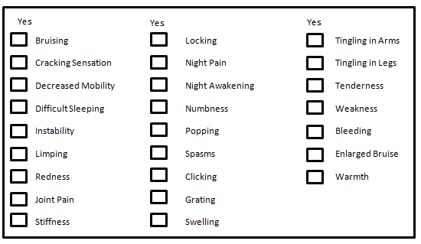

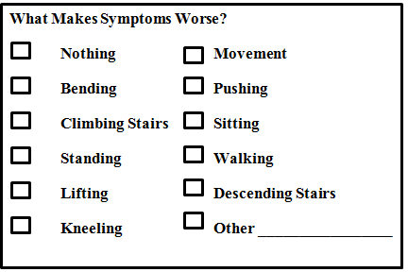

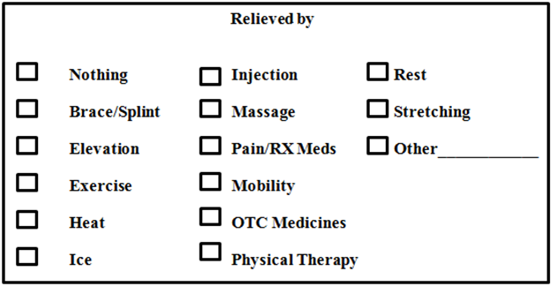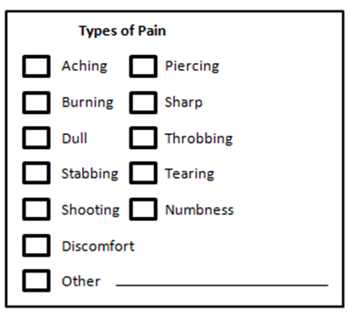

ARE YOU CURRENTLY EXPERIENCING? (REVIEW OF SYSTEMS)

Fever Significant Weight Change Vision Problems Cough/Cold Symptoms

Shortness of Breath Chest Pain Heart Palpitations Diarrhea Constipation

Urinary Incontinence Pain with Urination Joint Pain Chronic Headache

Rash on Affected Limb

Patient Name: ______________________________________ Today’s Date: ______________________

Surgical History: Date:

Please list any treatment pertaining to today’s complaint (injections, physical therapy, medications…): Date: Date

Medication: Dosage: Direction/How Taken:
Additional information please write on the back of this page.

Family History

Condition: Family Member: Comments:
Additional information please write on the back of this page.

Pharmacy: ***All fields required***
Pharmacy Name: | Address: | Phone:

Environmental Allergies: Drug Allergies: Food Allergies:
- None  - Latex  - Adhesives  - Other:  - _______________ | - None  - __________________  - __________________  - __________________  - __________________ | - None  - Peanuts  - Shellfish  - ____________________  - ____________________

PAST MEDICAL HISTORY ***All Fields Required***
Name | Date:
Have you ever had or currently have any of the following (mark all that apply):

Social History Circle your responses
Females – Any chance you may be pregnant? : Yes No |  |  |  |  |  | Do you live alone or with family?
Receiving Hospice Care?: Yes No Are you in Skilled Nursing or an Inpatient Rehab Facility? Yes No
Activity Level: Low Moderate Active

Current Smoker Former Smoker Non-Smoker |  |  |  |  |  |  | If former how long ago did you quit?
If current how often?: | How many per day: |  |  |  |  |  |  |  |  | Interestead in Quiting? Yes No
Do you consume alcohol?: Yes No |  | How Often: |  |  |  |  |  |  | How Many Drinks?:
Have you ever used illegal drugs?: Yes No |  |  |  | Type: |  |  |  |  |  | Currently?
Have you been addicted to prescription medications?: Yes No |  |  |  |  | Type?:
Do you drink caffeinated beverages? Yes No |  |  |  | How many cups per day?:
- Deep Vein Thrombosis
- Fibromyalgia
- Gallbladder Disease
- GERD
- Gout
- Heart Attack
- High Cholesterol
- Hypertension
- Ulcerative Colitis
- Juvenile Rheumatoid Arthritis
- Kidney Disease
- Liver Disease
- Lyme Disease
- Migraine Headaches
- Multiple Sclerosis
- Obesity
- Osteoarthritis
- AIDs/HIV
- Tuberculosis
- Hepatitis
- Alcoholism
- Alzheimer
- Anemia
- Angina
- Asthma
- Atrial Fibrillation
- Benign Prostatic Hypertrophy
- Cancer
- Congestive Heart Failure
- COPD
- Coronary Artery Disease
- Crohn’s Disease
- Depression
- Diabetes
- Drug Abuse (illegal or Rx)
- Osteoporosis
- Parkinson Disease
- Peptic Ulcer Disease
- Psoriasis
- Peripheral Vascular Disease
- Renal Disease
- Rheumatoid Arthritis
- Scoliosis
- Seizure Disorder
- Sleep Apnea
- Stroke
- Systemic Lupus Erythematous
- Spinal Stenosis
- Spondyloarthropathy
- Traumatic Arthritis
- Thyroid Disease
- Valvular Disease

