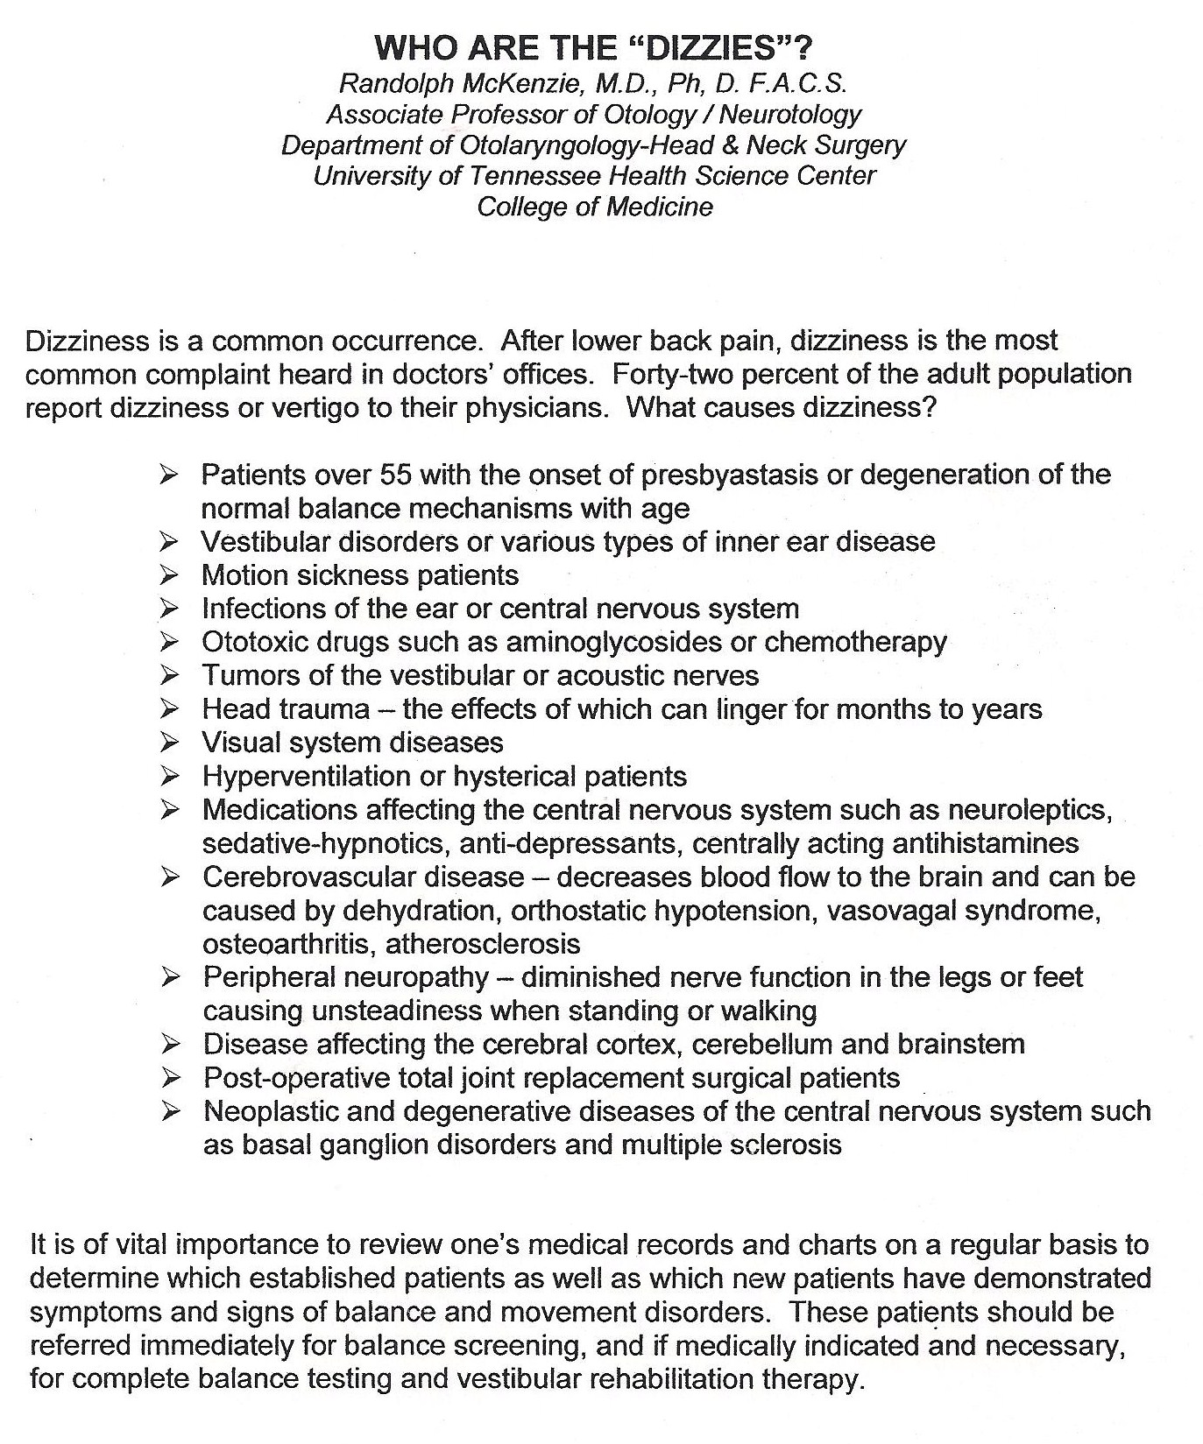
Please Call for further information at (310) 775-7795

